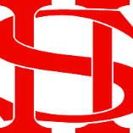
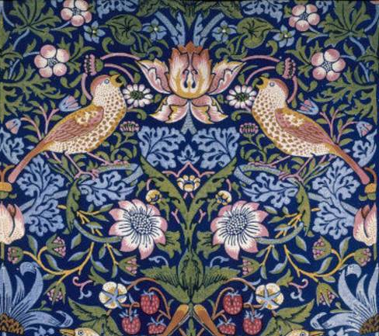
Art Remote Learning Lesson
Y8 Environment 2

Print off the sheet to work on or do the task on plain paper or in your book. Bring your work to your next lesson. If working on plain paper do the whole image.
Starter
State the main Formal elements in Art you can see in this artwork by William Morris and describe how you will recreate it. _______________________________________________
_________________________________________________
Main Task
Using pencil, draw the other half of the design below, as accurately as possible. Colour it if you wish.
Choose 4 questions from the HOTS sheet to answer about the image above.
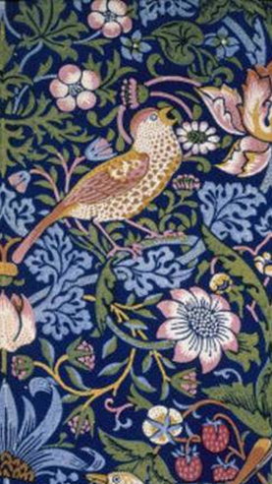

Extension: Do a close-up section in PEN here. Perhaps a bird’s head or flower?

Plenary

What Went Well:

Even Better:

