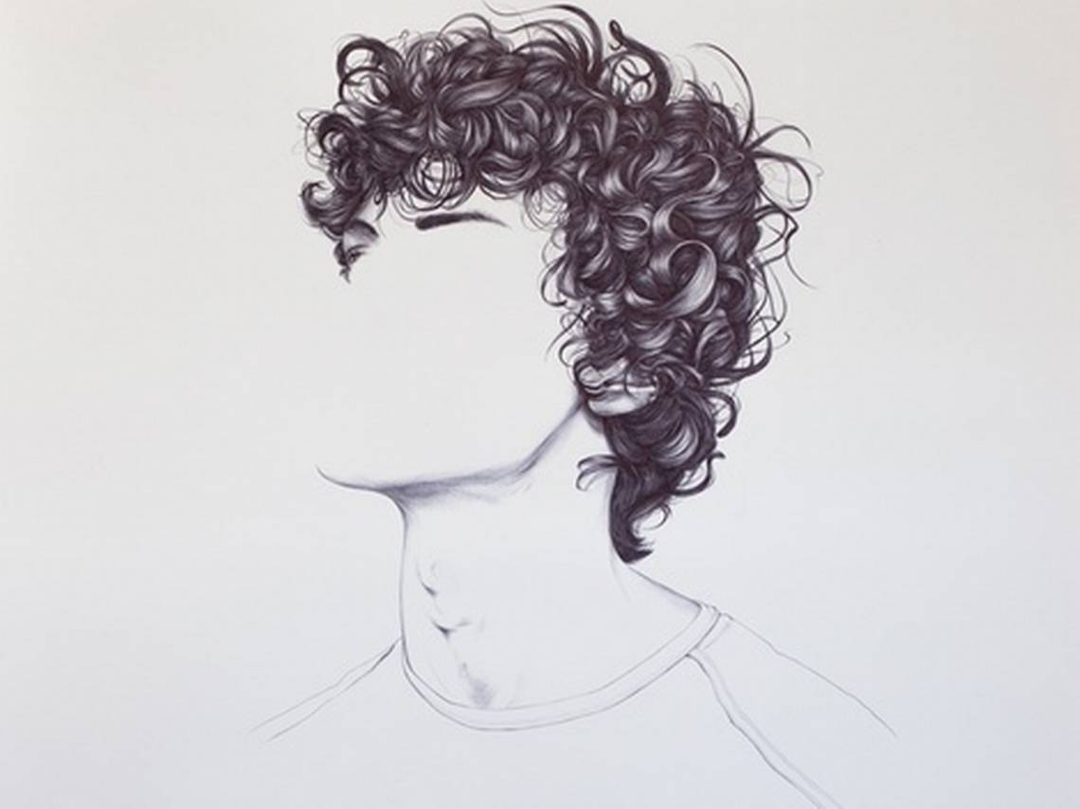
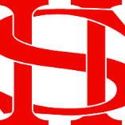
Art Remote Learning Lesson
Year 8 In A Different Way 4

Print off the sheet to work on or do the task on plain paper or in your book. Bring your work to your next lesson. If working on plain paper do the whole image.

STARTER
State the main Formal Elements in Art you can see in this portrait by Henrietta Harris. Describe how the image links to your project. _____________________________________
_____________________________________
_____________________________________
Main
Using pencil, draw the rest of the image below, as accurately as possible. Use a good variation of tone. Choose 4 questions from the Hots sheet, 1 from each section and answer them fully about the image.

Extension: Create your own portrait in the box, do it in the style the artist & use pen/biro

Plenary

WWW: ___________________________

EBI:______________________________

