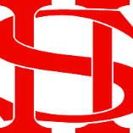
Art Remote Learning Lesson
Y7 Culture 3 – African Art

Print off the sheet to work on or do the task on plain paper or in your book. Bring your work to your next lesson.
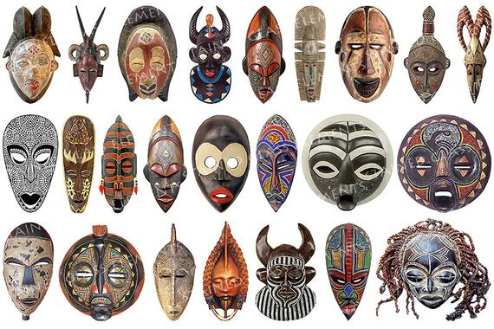
Starter
What words would you use to describe the expressions on the faces of these African Masks?
__________________________________________________________________________________________

___________________________________________________________________________________________
Main Task
Complete the other half of the African Mask. Use your usual drawing pencil and shade it in. Try to show the range of tone from light to dark. Choose 4 questions from the HOTS sheet to answer about one the masks above.

Extension: Design or make your own African inspired mask

Plenary

What Went Well:

Even Better:

