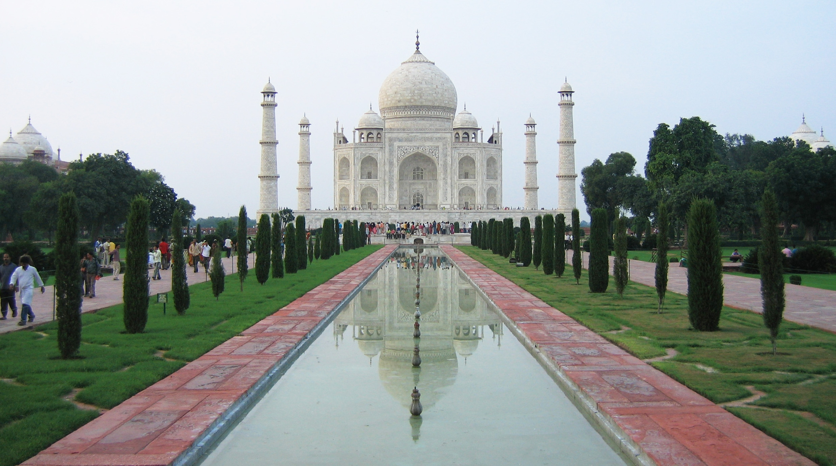
Art Remote Learning Lesson
Y9 Architecture Taj Mahal 5

Print off the sheet to work on or do the task on plain paper or in your book. Bring your work to your next lesson.

Starter
Describe the Taj Mahal using Formal Element Language. What is unique about it?
__________________________________________________________________________________________

___________________________________________________________________________________________
Main Task
Using a pencil, complete the missing half of the picture below.
Choose 4 questions from the Hots sheet, 1 from each section and answer them fully about the image below.

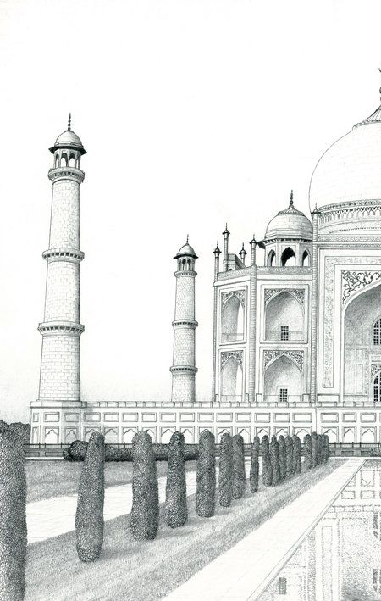

Extension: Draw another famous landmark that shows symmetry.

Plenary
Www:

EBI:

