Art Remote Learning Lesson 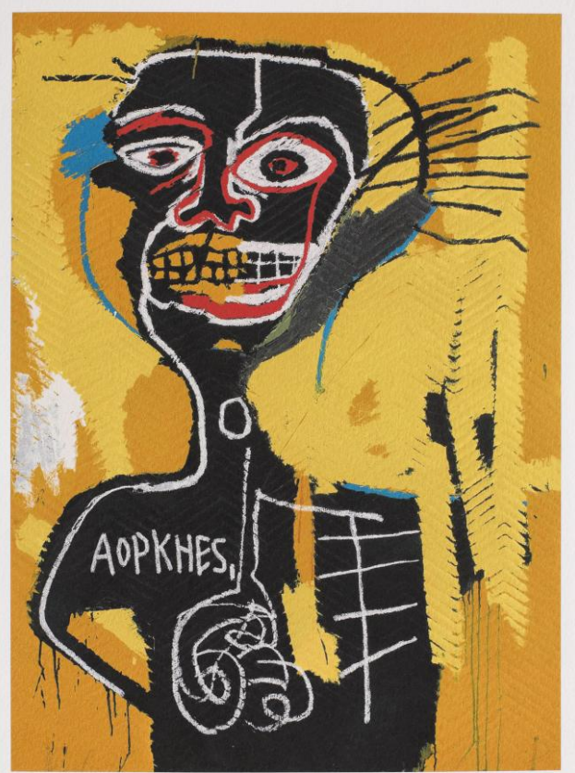
Year 9 Political Art 5

Print off the sheet to work on or do the task on plain paper or in your book. Bring your work to your next lesson. If working on plain paper do the whole image.

STARTER
Look at this self-portrait by Jean Michel Basquiat. He often used symbolism and his work was often about consumerism, political issues, and his black heritage. Describe the face and then try to explain what it might symbolise. ___________________________________________________________
___________________________________________________________
___________________________________________________________
Main
Using media of your choice, draw the rest of the painting below, as accurately as possible and colour it.
Choose 4 questions from the Hots sheet, 1 from each section and answer them fully about the image.

Extension:
Create a portrait in the same style here. Think about who will be in it and why. Can you use symbolism?

Plenary
This artist links to our project because (write why you think it links to our project)…………………………………….
……………………………………………..
……………………………………………..
……………………………………………..
……………………………………………..
……………………………………………..
……………………………………………..

