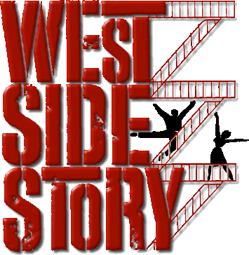
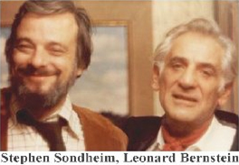
Background information:
- Composed in 1959, with music by Leonard Bernstein and lyrics by Stephen Sondheim.
- It is a retelling of Romeo and Juliet, where the Jets and Sharks have been reimagined into white polish Americans and Puerto Rican immigrants.
- This musical was seen as a turning point in musical theatre due in part to the sophisticated music and focus on social themes.
- The Jets and Sharks were originally imagined as Irish and Jewish, but it was felt that the eventual choice was more pertinent.

Questions – Opening Scene
- Describe the dynamics at the beginning:
_______________________________________
- After the finger-clicking starts, what is the string playing technique?
________________________________
- What rhythmic device is used in this piece?
________________________________
- Describe 3 ways that the music mirrors the action on screen:
- ______________________________________________________________________________
- ______________________________________________________________________________
- ______________________________________________________________________________

- Name 2 percussion instruments you hear in this piece:
__________________________________________________________________________________________
- Describe the mood of the piece, using musical words to support your description:
_________________________________________________________________________________________________________________________________________________________________________________________________________________________________

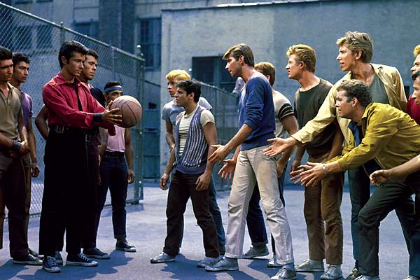
Much of the slang used in West Side Story was invented as it was feared real slang would become outdated.
Key Songs
Maria (Tony), America (Puerto Ricans), Tonight (Tony and Maria), One Hand, One Heart (Tony and Maria), I Feel Pretty (Maria and Girls), Somewhere (Company), Gee, Officer Krupke (Jets), A Boy Like That (Anita and Maria),

