
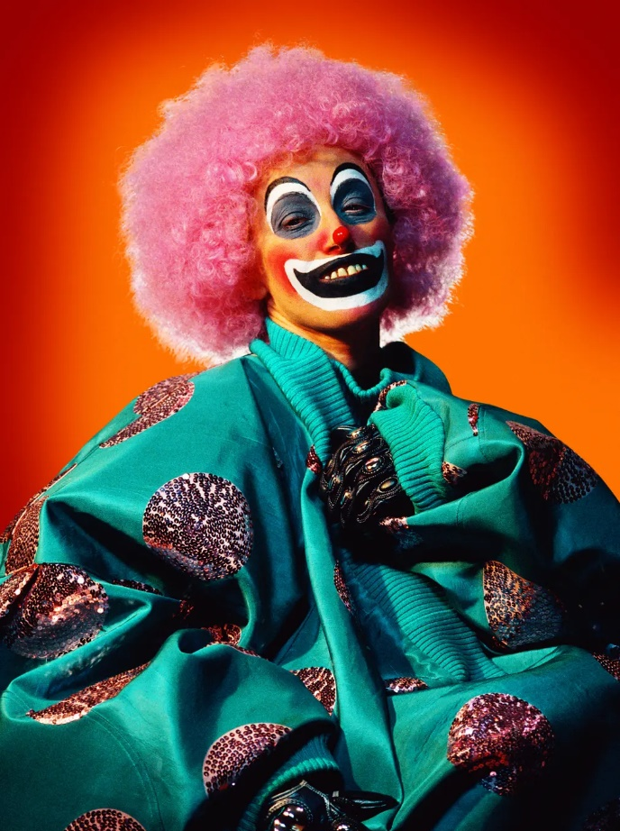
Art Remote Learning Lesson
Year 7 Identity 2

Print off the sheet to work on or do the task on plain paper or in your book. Bring your work to your next lesson.
Cindy Sherman is a contemporary photographer. She stages elaborate ‘selfie’ style photos where she dresses up in costume and portrays different characters. Her art is humorous, unsettling, and provocative.
“I am trying to make other people recognize something of themselves rather than me”. Cindy Sherman

STARTER
State what is in the picture. Describe the mood of the picture. Why do you think she has created this image? __________________________________________________
__________________________________________________
Main
- Using pencil or colours, draw and shade the image in the space below, as accurately as possible. Make it nice and big.
- Choose 4 questions from the Hots sheet, 1 from each section and answer them fully about the image.
Extension: Create a photograph of a character, fictional or non-fictional? Have fun – who will be in your photo? How will you dress up? How will you create the mood? Bring your photo to next lesson.
Plenary
Write a paragraph to explain why you think this Artist links to our theme of Portrait and Identity.
______________________________________________________________________________________________________________________________________________________________________
__________________________________________________________________________________

