
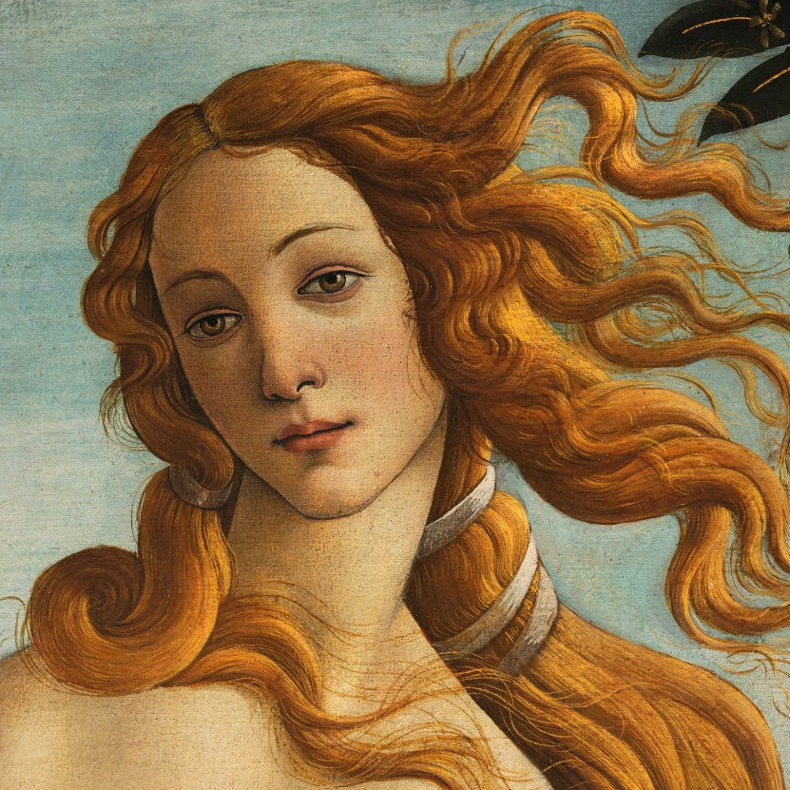
Art Remote Learning Lesson
Year 7 Identity 3

Print off the sheet to work on or do the task on plain paper or in your book. Bring your work to your next lesson.

Born in 1445, Sandro Botticelli was an important painter during the Italian Renaissance. He is known for the dreamy look of the people (and gods, goddess, and angels) in his paintings. People happily paid him to paint masterpieces for them or their churches.
STARTER
State the formal elements in art you see and describe how they are used in his painting of Venus here. ______________________________________
______________________________________
Main
Using pencil & colour, copy the painting in the space below, as accurately as possible.
Choose 4 questions from the Hots sheet, 1 from each section and answer them fully about the image.
Extension: Can you draw someone in the ‘dreamy’ style of Botticelli? Do your own portrait on a new piece of paper. Bring it to next lesson.
Plenary
Write a paragraph to explain why you think this Artist links to our theme of Portrait and Identity.
______________________________________________________________________________________________________________________________________________________________________
__________________________________________________________________________________

