
Art Remote Learning Lesson
Y9 Skills workshop 3

Print off the sheet to work on or do the task on plain paper or in your book. Bring your work to your next lesson.
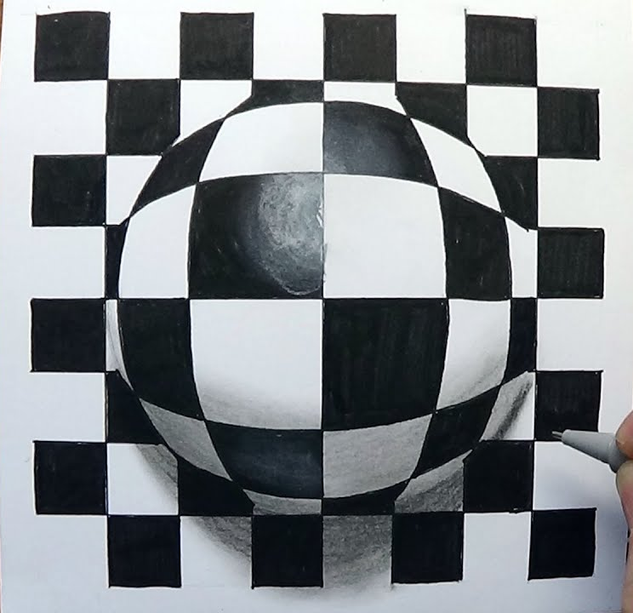
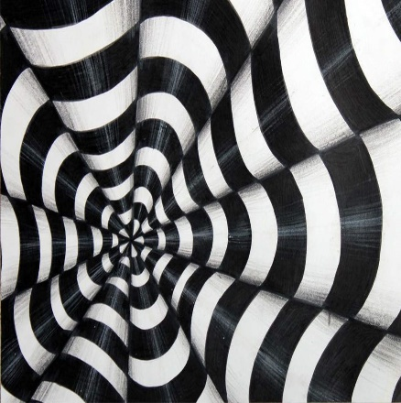
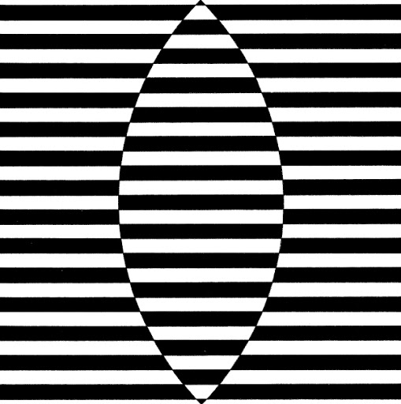
Starter
Look at these 3 Op Art images by Bridget Riley, what are the main formal elements used? Circle the ones you think -
LINE TONE COLOUR TEXTURE SHAPE PATTERN FORM

Main Task
Copy one of the above images.

Extension: Create your own Optical Illusion in your book or on paper.

Plenary
Describe WWW and what you would do better next time
…………………………………………………………………………………………………………………................................................................................................................................................................................................................................................................................................................................................................................................................................................................................................................................

