Coronavirus Story – The Kennet Federation

School will be different for a few weeks because most of our friends are learning at home.
Most children are staying at home because of the Coronavirus. People who catch Coronavirus may have a fever, sore throat/ dry cough or shortness of breath.

Most people who have Coronavirus will stay at home and get better. Some people will have to go to hospital to get better.

Lots of people are staying at home to stop Coronavirus from spreading.

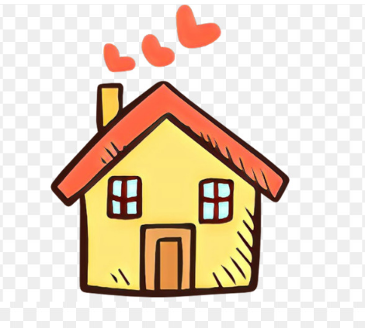

A few children are allowed to come to school if their parents have important jobs like working in hospitals or shops or delivering goods.




Children who are at home will be completing work set by their teachers.

Children at school will be cared for and kept safe by teachers.
Children at school will have lots of activities to do including gardening, art, karaoke, dancing and exercise.
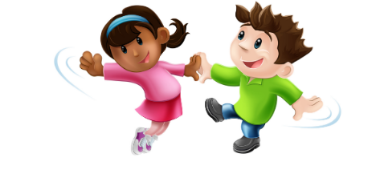

Children will need to listen to their teachers very carefully and follow something called ‘The Hygiene Protocol’. Your teachers will talk to you about this.

We all need to wash our hands for 20 seconds every time we go into a new area

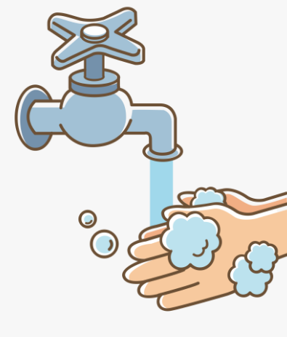
Sing the ‘happy birthday’ song to yourself twice when you are washing your hands.
We need to keep 2 arm lengths away from our friends and teachers.
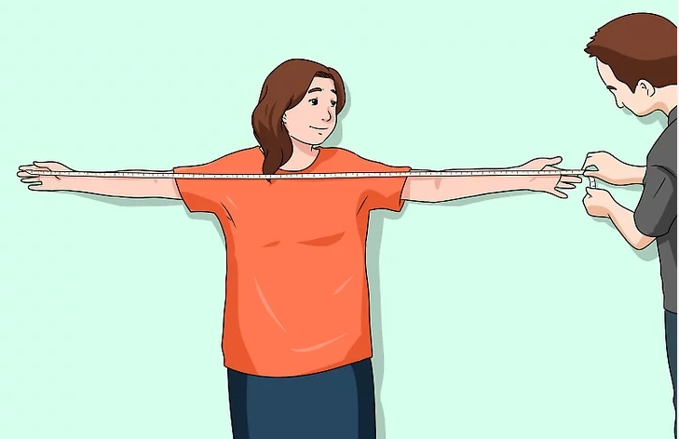

School will re-open for everyone when it is safe for everyone to be together again

