How to login to Office 365
First go to Google and type in Office 365. Click the top link:

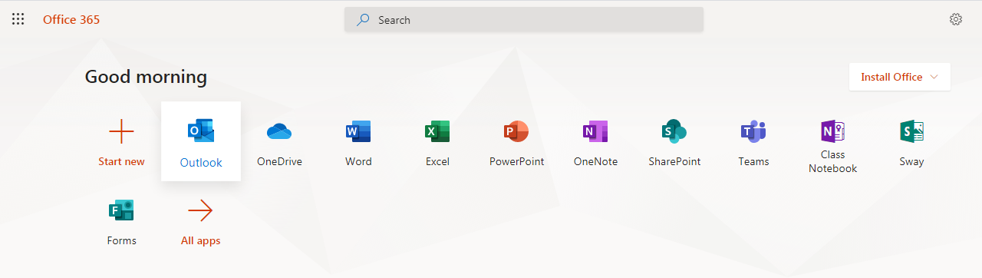
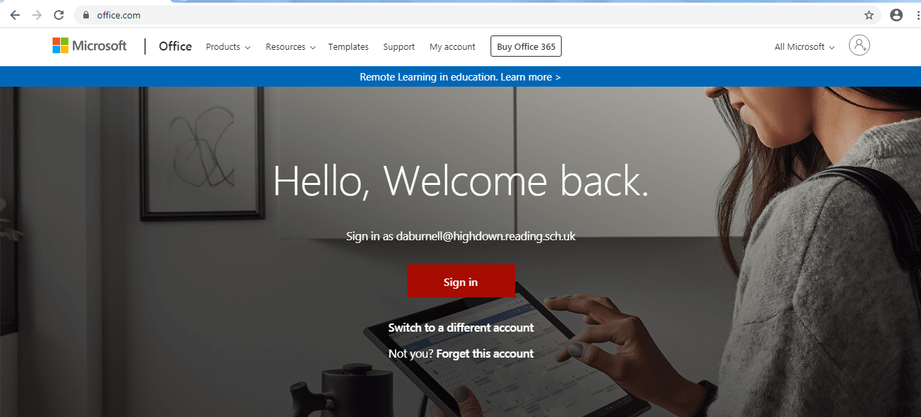
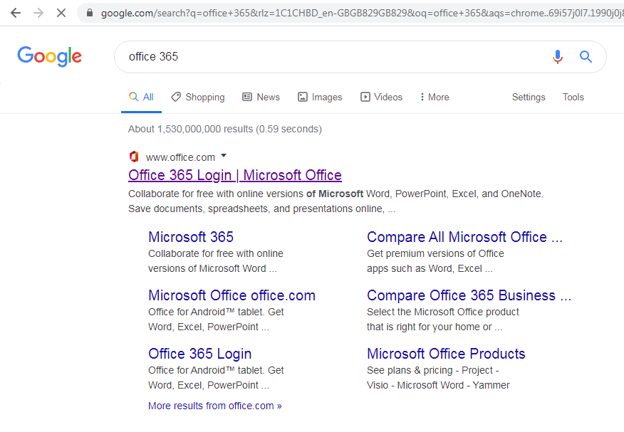
Now you have access to your emails. Click “New Message”
In the “To” section type in your “Buddy 1, and Buddy 2” Office 365 Student email address. This will be a four-digit number followed by @highdown.reading.sch.uk

Enter your log in details; (Username= school email address, and password.) Then click “Outlook”:

Click sign in:

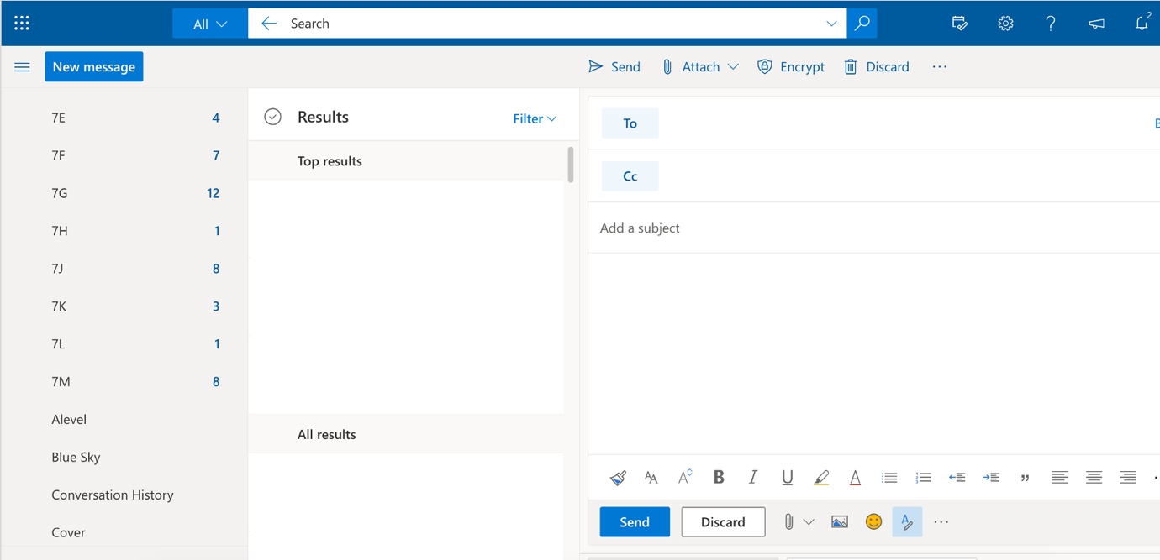

Add a subject “Hello Buddy”
Then type your message…
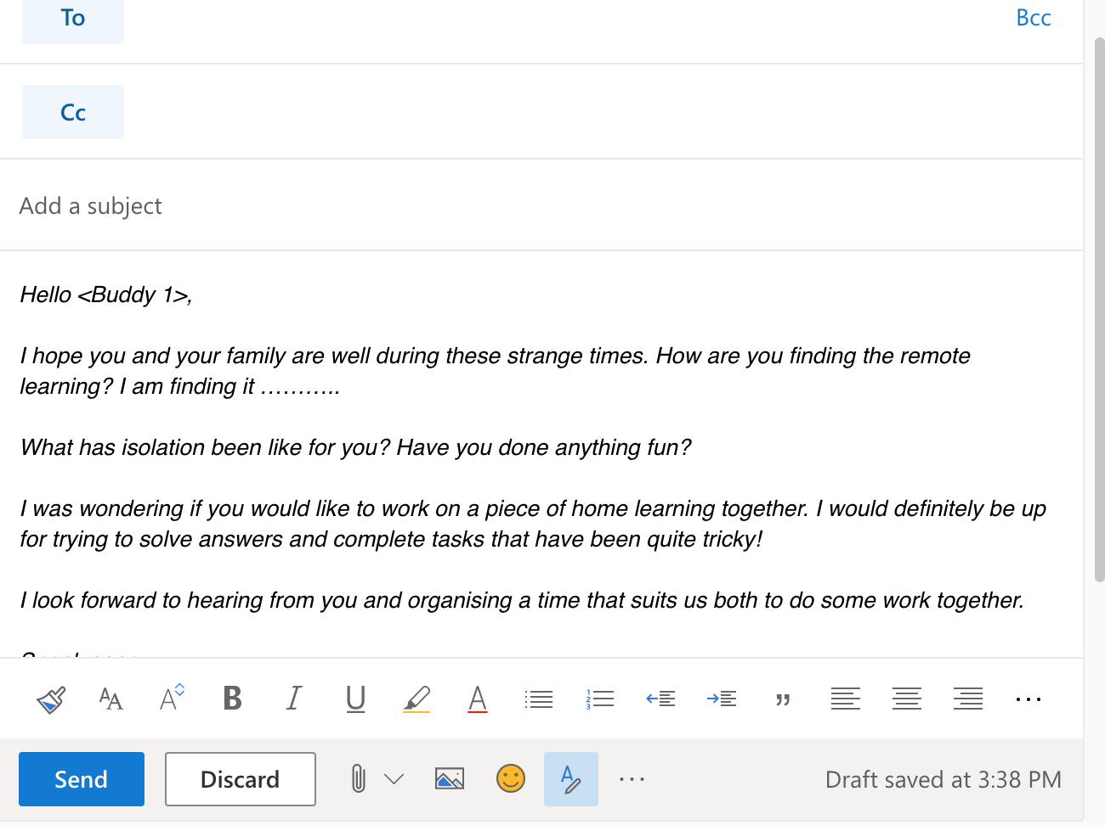
Once you’re happy click “Send” and await a response! It will show in your Office 365 “Inbox”.
Any problem’s please contact you mentor who will be able to advise! – You could add this to a PIXL Edge task for Initiative or Resilience!

