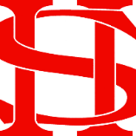
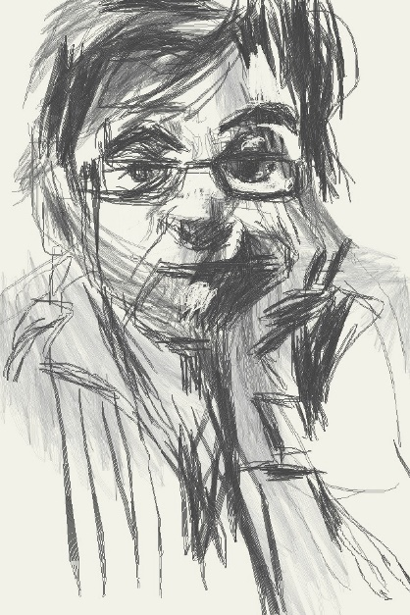
Art Remote Learning Lesson
Y7 Formal Elements in Art 1

Print off the sheet to work on or do the task on plain paper or in your book. Bring your work to your next lesson. If working on plain paper do the whole image.
Starter
State the main Formal element in Art you can see in this portrait by MANUEL-SAN-PAYO, and describe how you will use your pencil to recreate it. ______________________________________________________________
_______________________________________________________________

Main
Using pencil, draw the rest of the portrait below, as accurately as possible. Choose 4 questions from the HOTS sheet to answer about the image above.

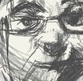

Extension: Do a close-up section in PEN here.

Plenary

What Went Well:

Even Better:

