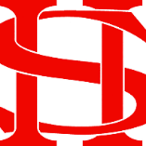
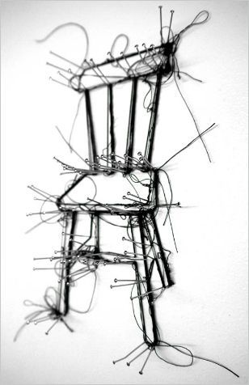
Art Remote Learning Lesson
Y7 Formal Elements in Art 2

Print off the sheet to work on or do the task on plain paper or in your book. Bring your work to your next lesson. If working on plain paper do the whole image.

Starter
State the main Formal element in Art you can see in this artwork by Debbie Smyth and describe how you will use your pencil to recreate it. ______________________________________________________________
_______________________________________________________________

Main Task
Using pencil, draw the rest of the chair below, as accurately as possible. Choose 4 questions from the HOTS sheet to answer about the image above.

Extension: Draw your own object in this style, in PEN here.
Plenary

What Went Well:

Even Better:

