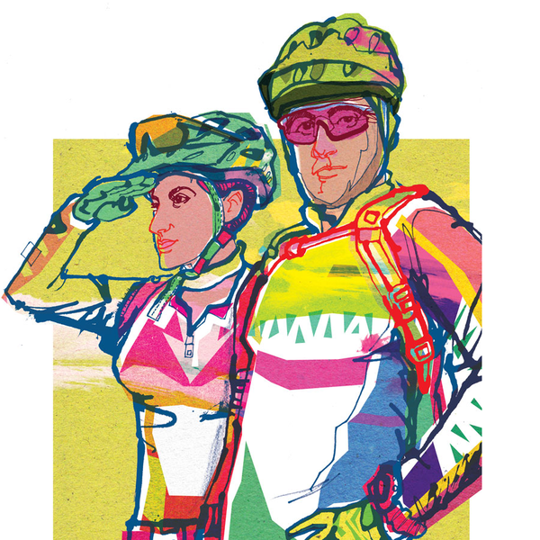
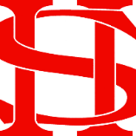
Art Remote Learning Lesson
Y7 Formal Elements in Art 3

Starter
State the main Formal element in Art you can see in this artwork by Dwayne Bell and describe how you will recreate it. ___________________________________
____________________________________________
____________________________________________
Main Task
Draw and colour the rest of the picture below, as accurately as possible.
Choose 4 questions from the HOTS sheet to answer about the image above.

Print off the sheet to work on or do the task on plain paper or in your book. Bring your work to your next lesson. If working on plain paper do the whole image.
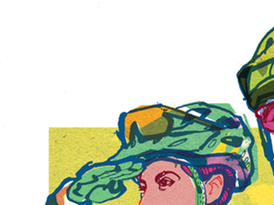

Extension: Draw and colour your own scene in this style here.
Plenary

What Went Well:

Even Better:

