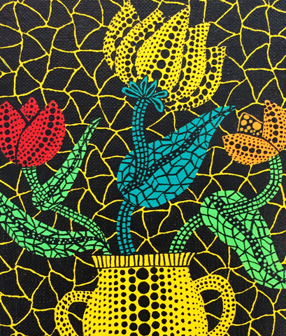
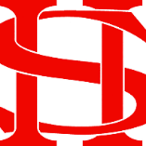
Art Remote Learning Lesson
Y7 Formal Elements in Art 4

Starter
State the main Formal element in Art you can see in this artwork by Yayo Kusama and describe how you will recreate it. __________________________________________________________
____________________________________________________________
Main Task
Draw and colour this picture, below, as accurately as possible.
Choose 4 questions from the HOTS sheet to answer about the image above.

Print off the sheet to work on or do the task on plain paper or in your book. Bring your work to your next lesson
Extension: Draw and colour a closeup section of it here. Do you have another material to use to colour it this time?
Plenary

What Went Well:

Even Better:

