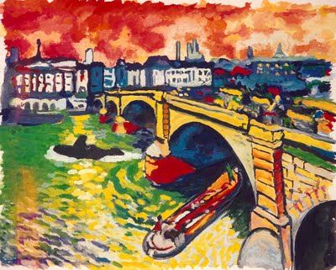
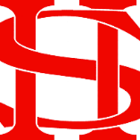
Art Remote Learning Lesson
Y8 Environment 5

Print off the sheet to work on or do the task on plain paper or in your book. Bring your work to your next lesson.

Starter
State the main Formal elements in Art you can see in this artwork by Derain and describe how you will recreate it. ________________________________________________________
________________________________________________________
Main Task
Using colours, copy the painting in the space below, as accurately as possible. Draw it first and then add colour. Choose 4 questions from the HOTS sheet to answer about the image above.
Extension: Draw a scene from your own environment and colour it in the style of the artist here.

Plenary

What Went Well:

Even Better:

