Year 9 French remote learning
Term 1

- Copy and translate these adjectives into English:
- Calme • Extraverti (e)
- Patient (e) • Introverti (e)
- Timide • Ouvert (e)
- Tranquille • Gentil (le)
- Branché (e) • Aimable
- Égoïste • Prévenant (e)
- Arrogant (e) • Doué (e)
- Drôle • Bavard (e)
- Marrant (e) • Silencieux, silencieuse
- Embêtant (e) • Paresseux, paresseuse
- Adroit (e) • Créatif, créative
- Maladroit (e) • Sérieux, sérieuse
- Pensif, pensive • Sympathique (sympa)
- Modeste • Vaniteux, vaniteuse
- Honnête • Pénible
- Têtu (e)

- Translate the verb ‘être’ (to be) in the present tense into English in your books:
Je suis
Tu es
Il/elle est
Nous sommes
Vous êtes
Ils/elles sont

- Write 10 sentences using the verb and adjectives above to describe yourself/ other people. Challenge – extend your sentences with connectives and intensifiers.

- Translate into French:
a) I am kind.
b) He is boring.
- She is talkative.
- My sister is lazy.
- We are shy.
- My sister is sporty.
- They are modest.
- I think that I am creative.
- My cousin (female) is very beautiful.
- My grandad is quite funny.
Challenge – write 5 of your own sentences. Try to include connectives and intensifiers.

- Copy the modal verbs into your books:
Pouvoir = to be able to
je peux = I can
il/elle peut = he/she can
nous pouvons = we can
ils/elles peuvent = they can
Vouloir = to want to
je veux = I want to
il/elle veut = he/she wants to
nous voulons = we want to
ils/elles veulent = they want to

Devoir = to have to
je dois = I have to
il/elle doit = he/she has to
nous devons = we have to
ils/elles doivent = they have to

- Translate: (check adjectival agreement!)
- I can be funny
- He must be hard working
- We want to be intelligent
- They can be annoying
- I have to be creative
- My mum wants to be sporty but my dad wants to be talkative.

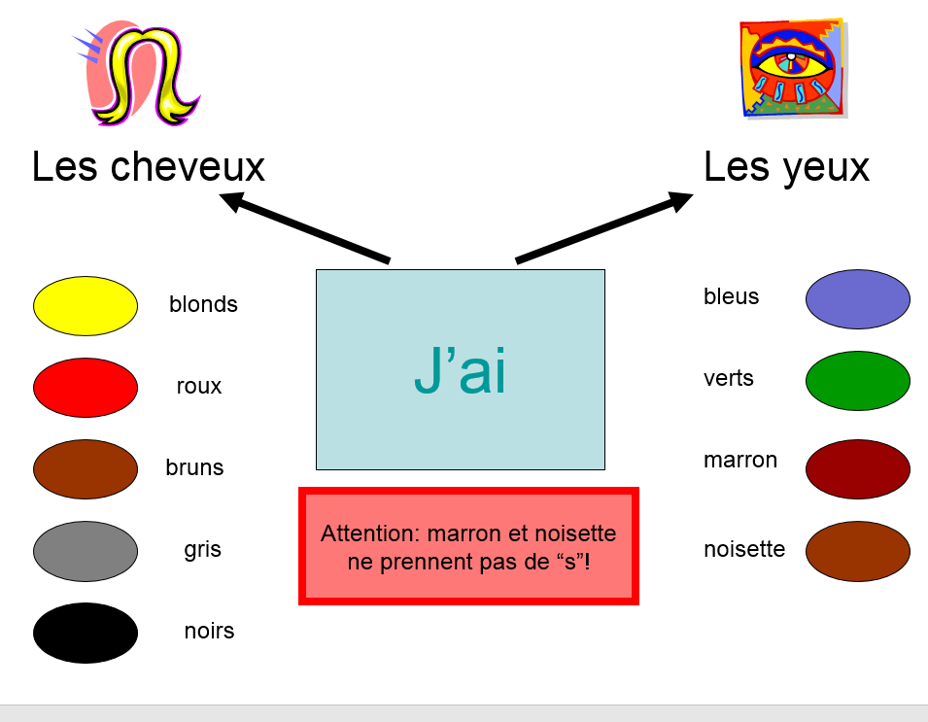
- Using the vocabulary below, write some sentences to describe what you look like. Make sure the colour comes after the word for ‘hair/ eyes’.

- Copy and translate the verb ‘avoir’ (to have) into English then write some sentences to describe what someone else looks like.
J’ai
Tu as
Il a
Elle a
Nous avons
Vous avez
Ils ont
Elles ont

- Find some extra words using www.wordreference.com and add them to your physical descriptions – e.g. I have curly and long hair. I am tall and thin.

- Copy the description of how to form the future tense in French into your book:
Take the present tense of ‘aller’ (to go) and add an infinitive verb.
Je vais – I am going
Tu vas – You (s.) are going
Il/elle va – He/she is going
Nous allons – We are going
Vous allez – You (pl.) are going
Ils/elles vont – They are going
E.G je vais jouer = I am going to play

- What do these verbs mean in English?
- Jouer
- Faire
- Aller
- Regarder
- Écouter
- Danser
- Manger
- Boire
- Habiter
- Chanter
- Avoir
- Être

- Copy and translate:
- Je vais jouer
- Je vais regarder
- Il va écouter
- Nous allons chanter
- I am going to eat
- She is going to dance
- We are going to drink
- They are going to live
- I am going to be
- I am going to have
Challenge – complete the sentences in French, e.g. I am going to eat chocolate because it’s delicious.

- Research a famous French person and try to find out (in English) as much information about them as possible. Use the below ideas to help.
Name:
Where from:
What famous for:
Background information on career:
Awards/ prizes
Family:
Hobbies/ interests:
Hopes/ aspirations:
Dislikes:
Personality:
Appearance:

- Write a paragraph about your chosen French celebrity.
There is vocabulary below to help you (which can also be copied as a vocabulary list into your book)
Il/elle est = he/ she is
Il/elle a = he/she has

Mari = husband
Femme = wife
Fils = son
Fille = daughter

Qui/il/elle s’appelle = who/he/she is called
Il/elle aime/adore = he/she likes/loves
Il/elle déteste = he/she hates
Parce que/ car = because

Il/elle va = he/ she is going to…
He/ she was born = il/elle est né(e)
He/ she played = il/ elle a joué
He/she lived = il/elle a habité
He/she worked = il/elle a travaillé
He/she was = il/elle était
He/she won = il/elle a gagné

Il/elle est mon idole parce que… = he/she is my role model because…
Pour être idole, il faut être… = in order to be a role model, we must be…

