Year 9 Chinese Remote Learning Term 1
Week 1 21/09/2020 – 24/09/2020
1. Trace the characters. Say them while tracing them. Learn to write these words from memory.
Quizlet link: https://quizlet.com/join/fjfRuxwZr You need to create an account and join the class with the link.
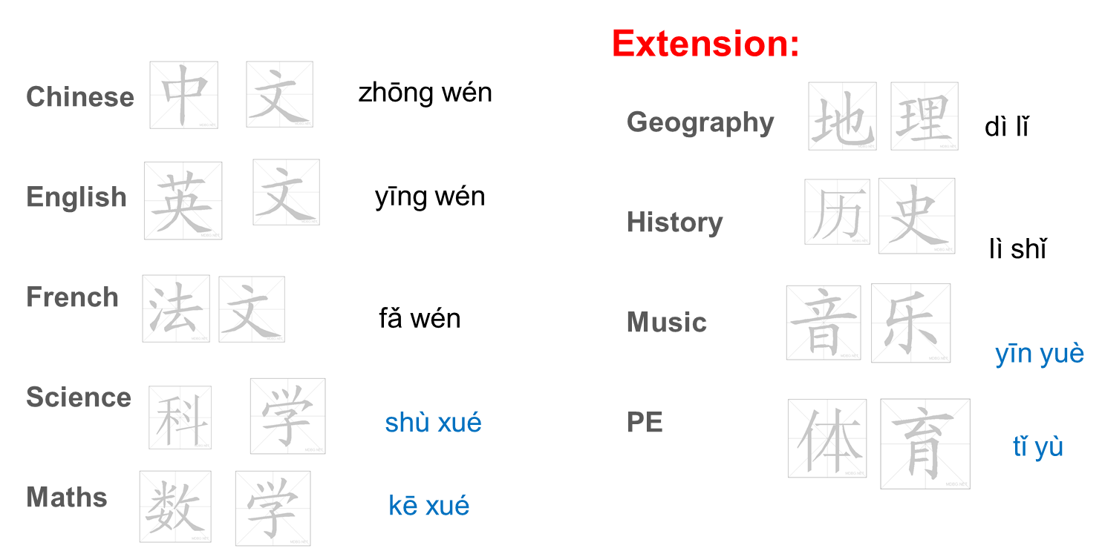
2. Complete a test on Quizlet.
3. Practise to write the following words.
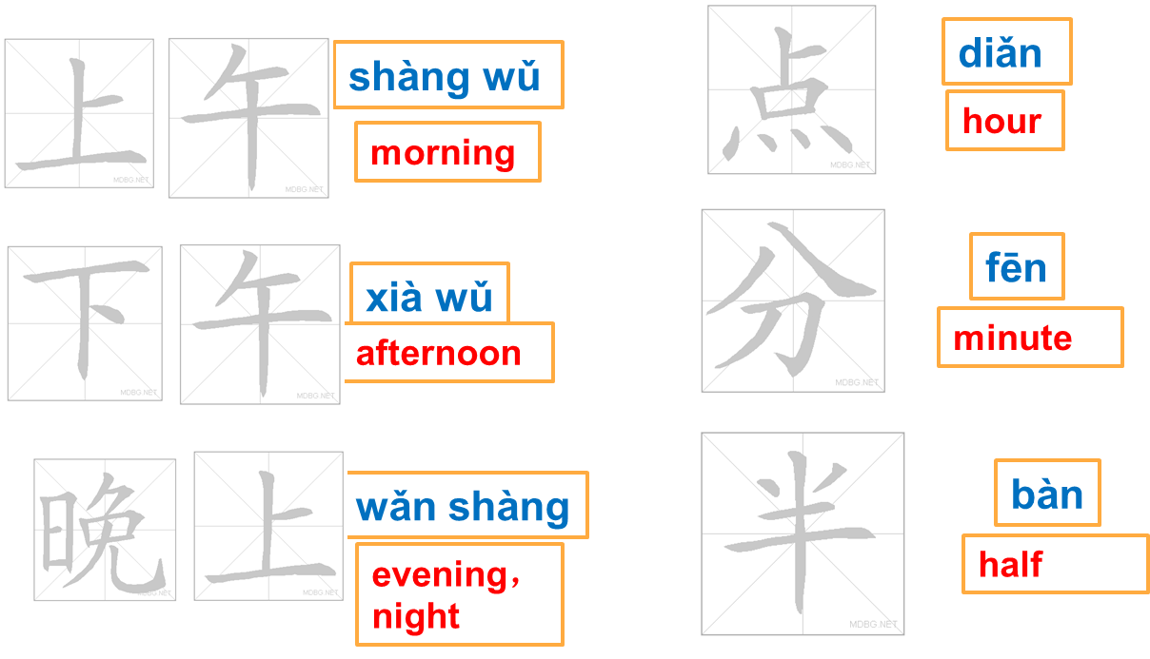

4. Apply the rules of the order of time phrases. Write down the time phrases in the correct order.
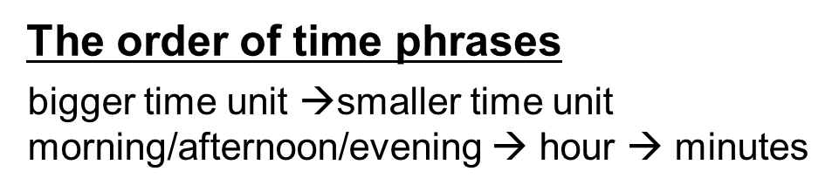
7am - 上午七点

9.30pm

3 o’clock

1.15pm

5. Write down the following times.
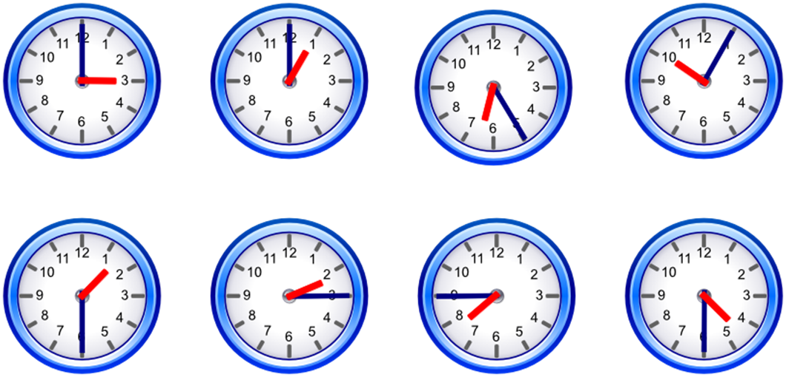

Week 2 28/09/2020 – 02/10/2020
1. Translate the following sentences into English, at least first 3
1.我九点有数学课。
2.我十点有英文课。
3.我两点有体育课。
4.我星期三十一点二十五分有音乐课。
5.她星期二有历史课。
6.他星期五一点半有地理课。
2. Write down these times in English
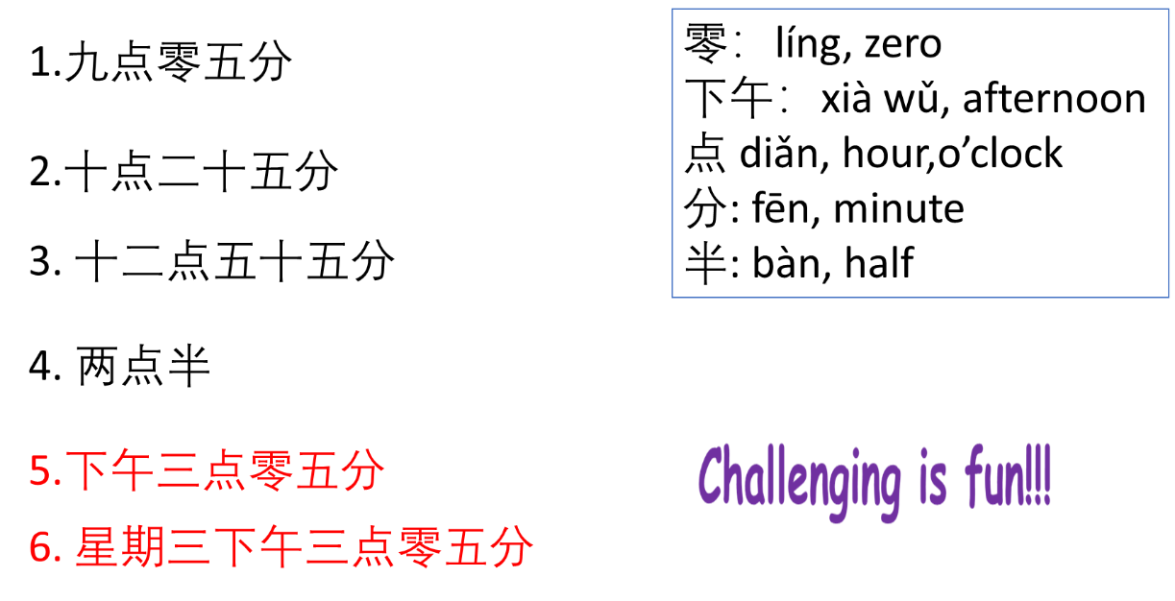
3. Trace the characters while saying them. Learn to write them from memory. Complete the test on your Quizlet class.
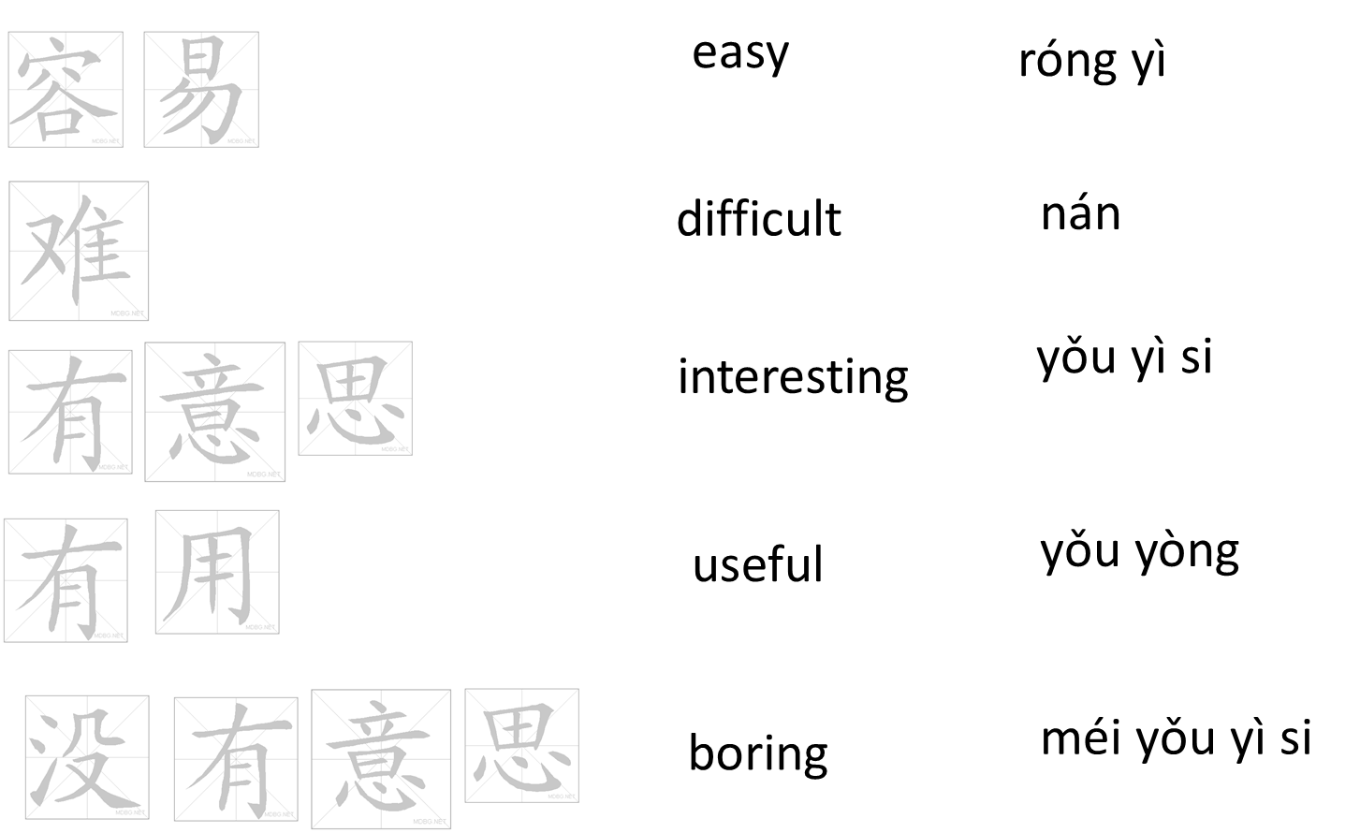

3. Learn to give opinions about school subjects:
我喜欢/不喜欢_________(subject), 因为 _______ (use the following sentence to justify your opinion.)

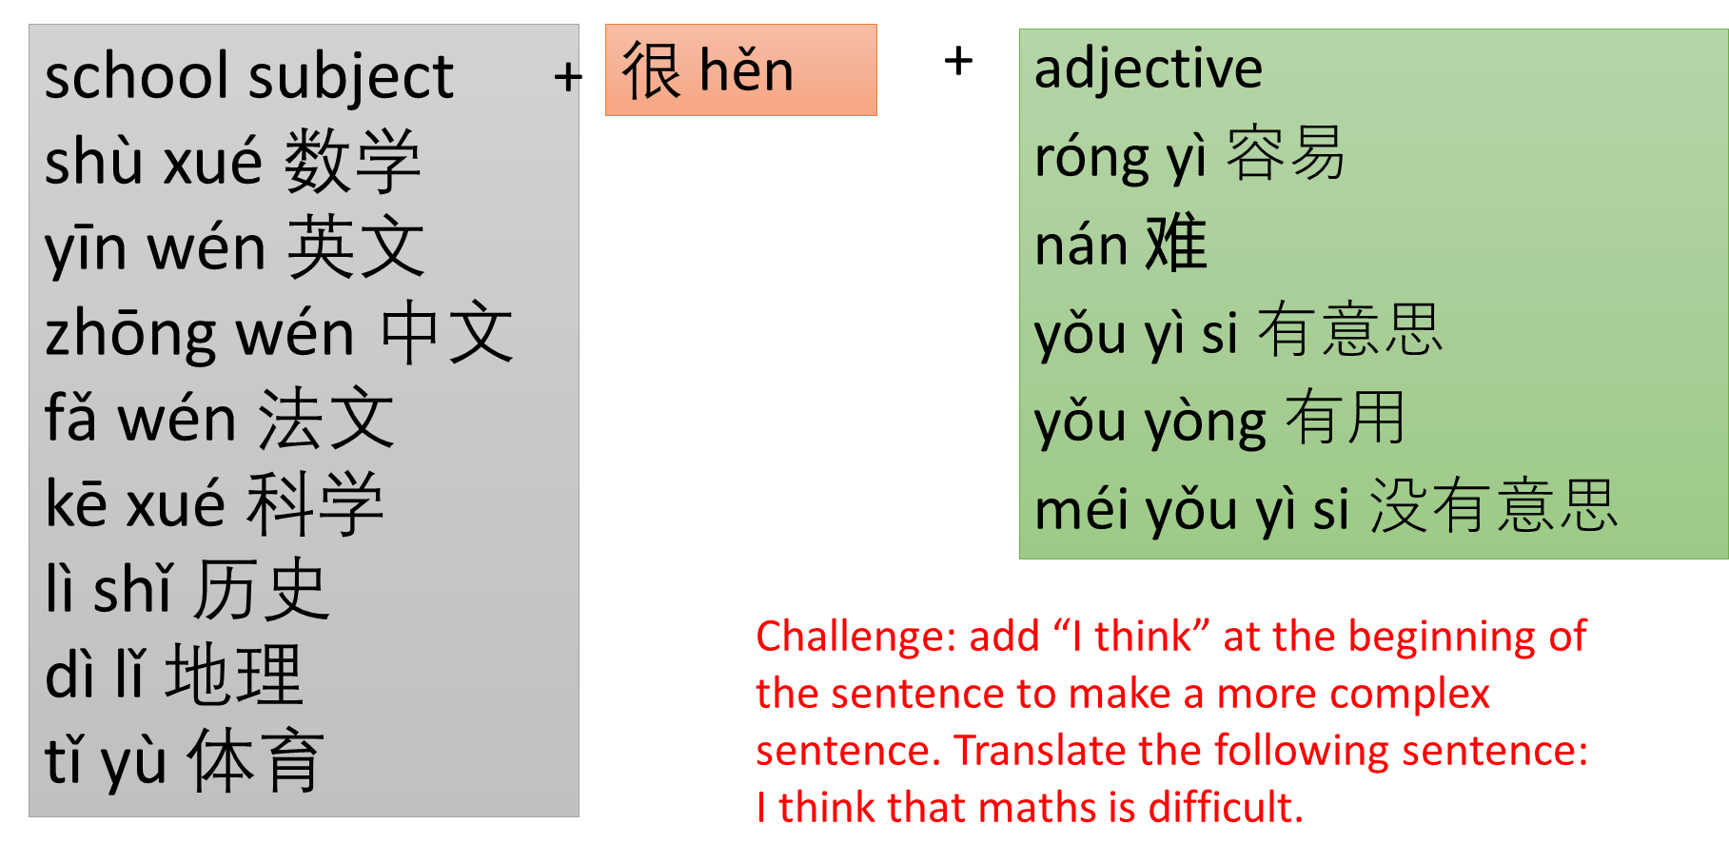

Week 3 5/10/2020 – 9/10/2020
A. Read the text and underline the phrases in the text. Please follow the example.
1. 我的学校- my school, wǒ de xué xiào
2. 九点零五分- 5 past nine, jiǔ diǎn líng wǔ fēn
3. 我不喜欢数学课- I don’t like maths lessons, wǒ bù xǐ huān shù xué kè
4. 数学很难- Maths is difficult. shù xué hěn nán
5. 星期二下午两点 Tuesday 2pm xing qī èr xià wǔ liǎng diǎn
6. 我觉得历史课很有意思 I think that history lessons are interesting. Wǒ juě de lì shì kè hěn yǒu yì si
7.我的体育老师 My PE teacher, wǒ de tǐ yù lǎo shī
8.我最喜欢 I like most, wǒ zuì xǐ huān
9.因为地理课没有意思 because geography lessons are boring, yīn wéi dì lǐ kè méi yǒu yì si
10. 但是科学很有用 but science is useful, dàn shì kē xué hěn yǒu yòng
我和喜欢我的学校。星期三上午九点零五分，我有数学课，我不喜欢
1
数学课，因为我觉得数学很难。我喜欢星期二，因为我星期二下午两
点有体育课，我很喜欢体育课和我的体育老师。我最喜欢历史课，因
为我觉得历史课很有意思。我也喜欢音乐课，因为音乐很容易。我不
喜欢课地理，因为地理课没有意思。我不喜欢科学课，但是科学很有
用。

B. Translate the above text into English.

Week 4 12/10/2020 – 16/10/2020
1. Learn to use paired connectives to make your writing/speaking more interesting.
Express opinions in contrast.
虽然…但是… “although… but…” suī rán …dàn shì
Although I like maths, (but) I think it’s difficult.
虽然我喜欢数学，但是我觉得数学很难。
Translate the following sentences into Chinese.
Although I don’t like science, (but) I think that science is useful.
Although I like history, (but) I think that history is sometimes boring.
Although I don’t like PE, (but) I think that PE is easy.
2. Translate the following sentences into English.
a. 我叫Ethan，我喜欢历史课，因为我觉得历史很有意思。
b. 我叫Emily,我不喜欢体育课，因为我觉得体育很没意思。
c. 我叫Phoebe,我不喜欢科学，因为科学太难了。
d. 我叫Joe, 虽然我不喜欢数学，但是我觉得数学很有用。
e. 我叫大一，我不但喜欢科学，而且也喜欢数学，因为我很聪明。

Week 5 19/10/2020 – 23/10/2020
Learn to talk about School Routine
1. Learn the following vocabulary and complete a test on Quizlet.

起床 qǐ chuáng, to get up
刷牙 shuā yá, to brush teeth
洗澡 xǐ zǎo, to have a shower/bath
穿衣服 chuān yī fú, to get dressed
吃早饭 chī zǎo fàn, to have breakfast
上学 shàng xué, to go to school
上课 shàng kè, to have lesson
课间休息 kè jiān xiū xí, to have break time
吃午饭 chī wǔ fàn, to eat breakfast
放学 fang xué. To finish school
做作业 zuò zuò yè, to do homework
睡觉 shuì jiào, to sleep
每天 měi tiān, everyday

2. Translate the text into English.
我每天八点半到学校。八点四十到九点四十上第一节课。上午有三节课，十一点四十到十二点十分课间休息。下午有两节课。我两点半吃午饭, 三点回家。
3. Make poster on a piece of A4 paper, using the following layout.


