Y8 MEP remote learning term 1

School subjects
- Copy the following in Chinese characters and translate them into English.
中文 英文 数学 科学 电脑 音乐 西班牙文 法文 德文 历史 地理 体育课 不仅 而且 但是非常 因为
- Find out how to write Drama, chemistry, history and biology in Chinese and write them in your books. You also need to write down the Pinyin for that.
- Design your week A timetable.
- Try to write down as many adj as you can remember
Eg. 有意思
- Copy the following 5 times and add pinyin to them and translate them.

有意思 没有意思 好玩 有趣 无聊 容易 难 有用
- Copy and translate
星期三，我不仅有中文课，而且有体育课；但是我没有数学课和历史课。我非常喜欢中文课因为有意思。

- Write a short passage to describe your opinions of school subjects.
Successful criteria:
Correct characters and sentence structures
Opinions + justification
Different intensifiers
Proper connective words

- What do you eat for breakfast?
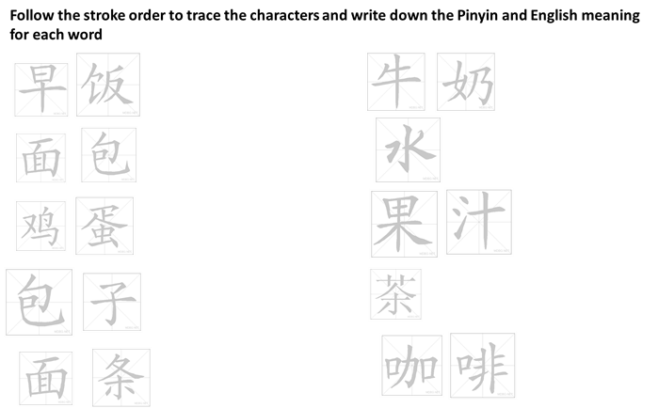

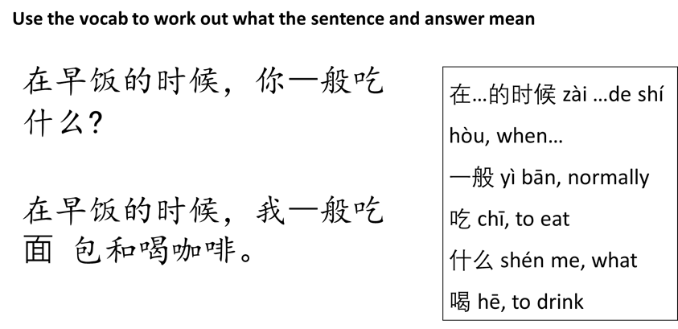

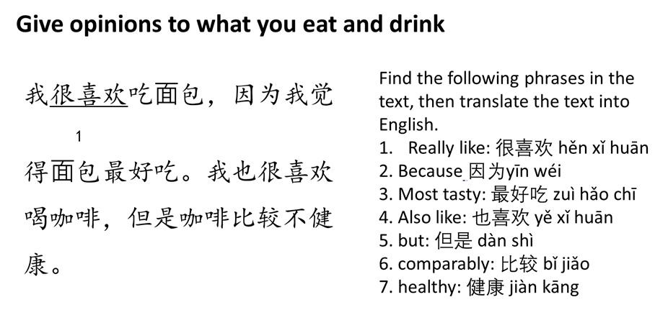

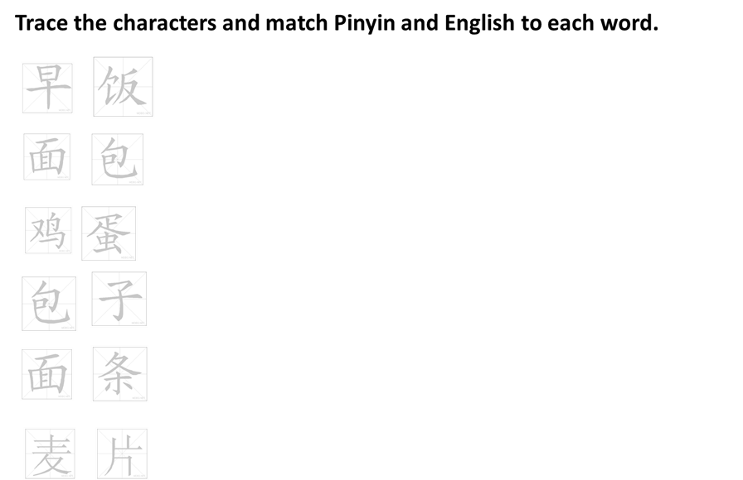
13.
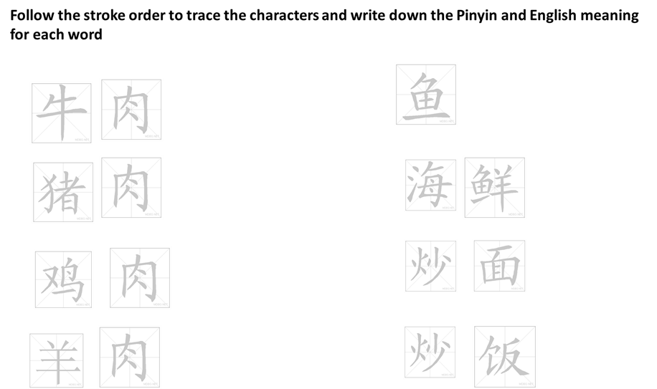

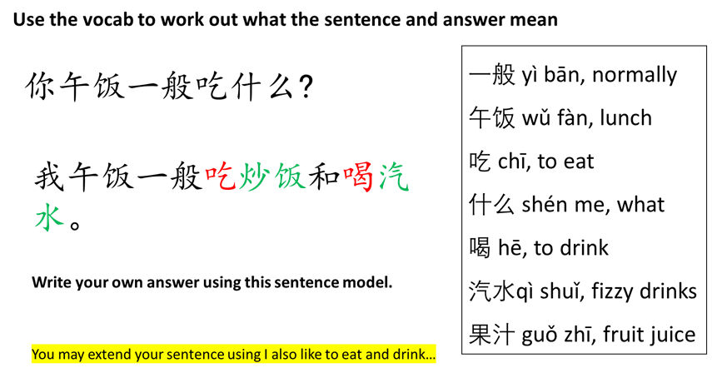
15
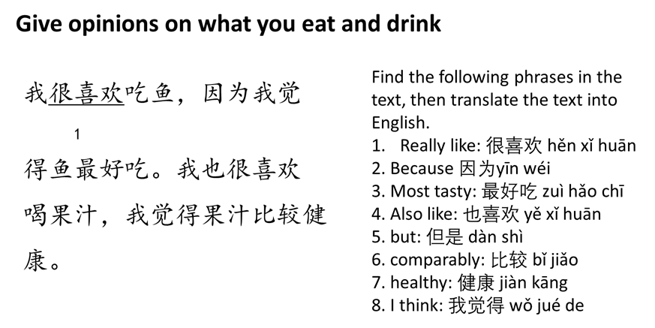

中文 | zhōng wén | Chinese | 法文 | French
英文 | yīng wén | English | 体育 | PE
数学 | shù xué | Maths | 历史 | History
科学 | kē xué | Science | 地理 | geography
电脑 | diàn nǎo | computer | 美术 | Art
音乐 | yīn yuè | music | 化学 | chemistry

Vocabulary List
在…的时候 | zài…de shí hòu | when… | 面包 | miàn bāo | bread
早饭 | zǎo fàn | breakfast | 鸡蛋 | jī dàn | egg
午饭 | wǔ fàn | lunch | 面条 | miàn tiáo | noodles
晚饭 | wǎn fàn | dinner | 包子 | bāo zi | dumplings with fermented dough
一般 | yì bān | normally | 饺子 | jiǎo zi | dumplings
 | yǒu shí hòu | sometimes | 炒面 | chǎo miàn | fried noodles
吃 | chī | to eat | 炒饭 | chǎo fàn | fried rice
喝 | hē | to drink | 鸡肉 | jī ròu | chicken
牛奶 | niú nǎi | milk | 牛肉 | niú ròu | beef
水 | shuǐ | water | 羊肉 | yáng ròu | lamb
茶 | chá | tea | 猪肉 | zhū ròu | pork
咖啡 | kā fēi | coffee | 鱼 | yú | fish
果汁 | guǒ zhī | fruit juice | 海鲜 | hǎi xiān | seafood
好吃 | hǎo chī | tasty | 不 | bù | not
不好吃 | bù hǎo chī | not nice to eat | 我觉得 | wǒ jué de | I think that
难吃 | nán chī | disgusting | 因为 | yīn wéi | because
健康 | jiàn kāng | healthy | 非常 | fēn cháng | extremely
比较 | bǐ jiǎo | relatively | 比 | bǐ | to compare
Sentence structure:
Paired connectives: 除了… 以外，我还… chú le…yǐ wài, wǒ hái… apart from..., I also…
很 structure: Subject + 很/非常/比较
Comparative sentence: A + 比 +B + adjective - A is more … than B.

