Lesson 2 Describing a City
Check list：
□ I can say where a city is located in a country
□ I can write a sentence in characters about the location of the city
□ I can use 很 structure to describe a city
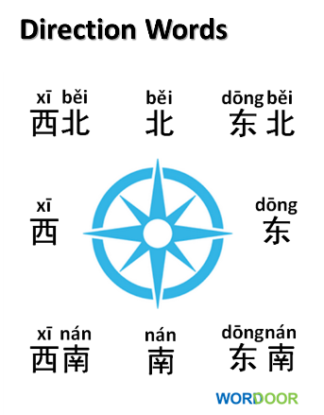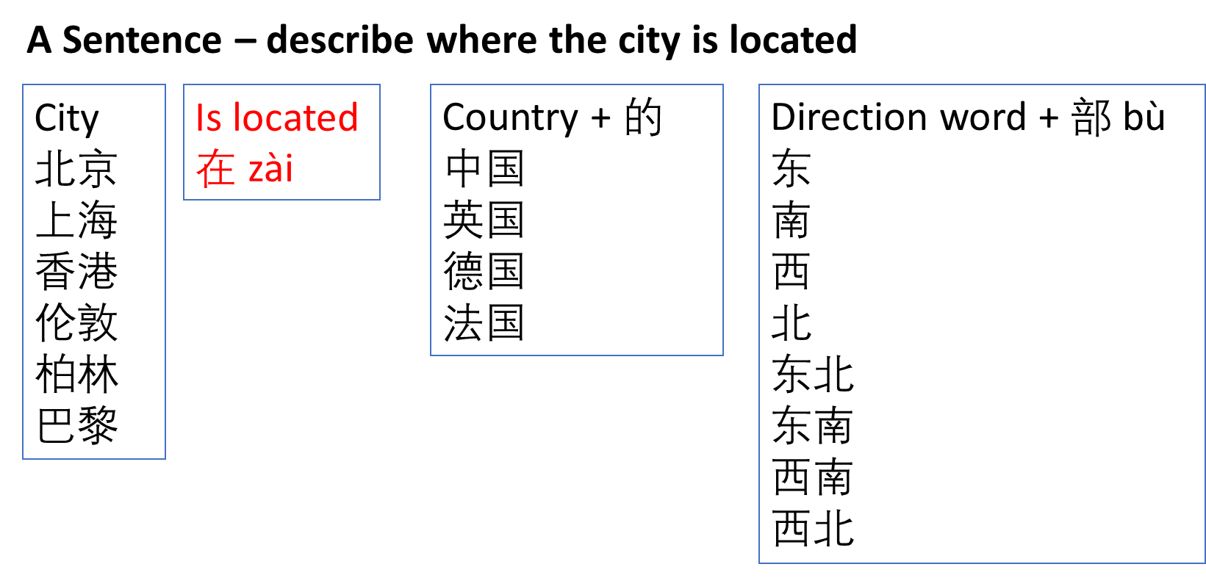
Use the sentence structure to write at least one sentence



