Vocabulary List f or Lesson 1 – Holiday Destinations
Time phrases |  |  | Countries
去年 | Qù nián | last year | 中国 | zhōng guó | China
春天 | chūn tiān | spring | 法国 | fǎ guó | France
夏天 | xià tiān | summer | 西班牙 | xī bān yá | Spain
秋天 | qiū tiān | autumn | 意大利 | yì dà lì | Italy
冬天 | dōng tiān | winter | 英国 | yīng guó | UK
People
家人 | jiā rén | family | 朋友 | péng yǒu | friend
我的 | wǒ de | my | 你的 | nǐ de | your (singular)
爸爸 | bà ba | dad | 妈妈 | mā ma | mum
哥哥 | gē ge | older brother | 姐姐 | jiě jie | older sister
弟弟 | dì di | younger brother | 妹妹 | mèi mei | younger sister
Verbs and tenses
去 | qù | to go | 了 | le | past marker
度假 | dù jià | to spend holiday

Check list：
□ I can say when and where I went on holiday +with whom
□ I can write a sentence in characters about when and where I went on holiday + with whom
□ I understand the positions of time phrases, past marker and “with + people”

Unit 1 Holiday
Lesson 1 Holiday Destinations Worksheet
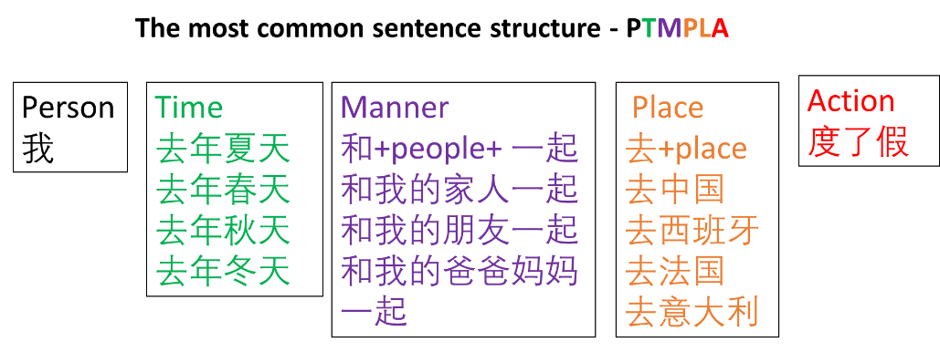
Use the sentence structure to write at least one sentence



