Year group: 7 | Lesson topic: 3 - Shooting
Link to video clip: https://www.youtube.com/watch?v=5Fa9LOGdUi0&list=PLh71vpzW5eHJUQB9-x6-xuaems9K2Na1F&index=51&t=0s (starts at 3m35)

Questions about skill:
- Which part of the foot should contact the ball when shooting with power?

- Where should your standing foot be placed when shooting?

- When shooting, which areas of the goal should you aim for?

- Which alternative part of the foot could be used to shoot with more accuracy?

Questions about video:
You may need to watch the video more than once to fully answer some of the questions:
- The first shot is missed (3min 40). What reasons can you think of that caused this player to miss?

- Find another example in the video of a shot that you think is missed for a different reason. Give the time in the video that it happens, and explain what reason you think caused the miss.

- Most of the goals scored go into which area(s) of the goal?

- Find an example of a great shot. Give the time in the video it happens, and explain why you think it was such a good shot.


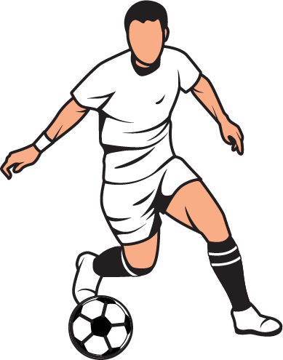
Football

