Weather and country Task 1
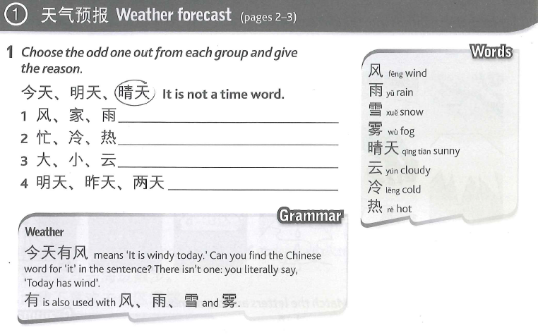
Task 2 and Task 3
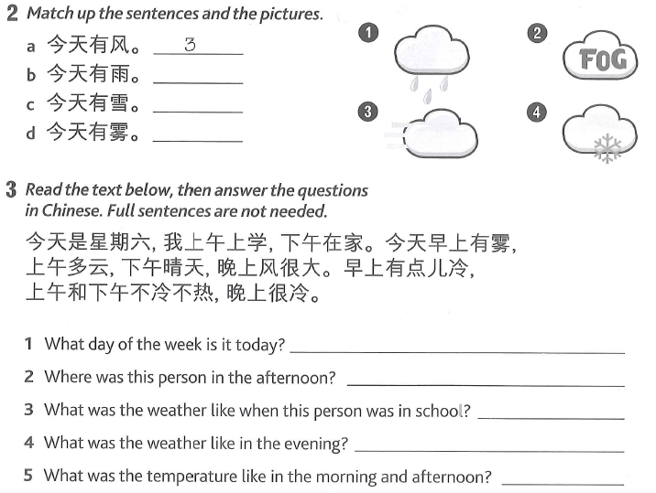

Task 4
天气 | 晴天 | 阴天 | 多云 | 热 | 冷 | 昨天 | 今天 | 明天 | 风 | 雨 | 雪 | 雾
weather | Sunny day | overcast | cloudy | hot | cold | yesterday | today | tomorrow | wind | rain | snow | fog
Copy 5 times

Task 5.
Copy the countries 5 times and draw the flag of the countries.
1中国 2英国 3法国 4美国 5日本 6西班牙 7德国 8加拿大
Task 6
Translate the following sentences into Chinese. You will need to write down your sentences in Chinese characters and Pinyin.
- China today rains but today England sunny day.
- Spain yesterday hot but yesterday UK not hot not cold.
- Germany today cold but tomorrow Germany hot.
- France today cloudy. UK today also cloudy.

Task7 Copy and translate
- 中国今天有雨。
- 英国明天有风。
- 美国今天有雪。
- 西班牙昨天晴天。
- 法国今天多云。
- 日本今天阴天。

Task8 Read the conversation and answer the questions
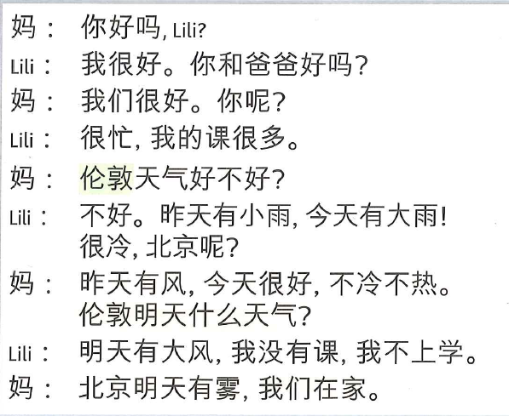
1.Lili is very busy.
2 Lili is busy because she has lots of homework.
3 According to Lili, it rained both yesterday and today in London.
4 It snowed in Beijing yesterday.
5 The weather today in Beijing is good because it is neither cold nor hot.
6 It will be cloudy in London tomorrow.
7 It will be foggy in Beijing tomorrow.
8 Lili has to go to class tomorrow.

Task 9
Read the following text and answer the questions.
我叫月月，我十二岁。我的生日是一月一日。我家有五口人：爸爸，妈妈，弟弟，妹妹和我。我是英国人。我说英文和中文。英国今天多云，明天有雨，昨天很冷。
Questions:
1. How old is Yueyue? When is her birthday?
2. What is her nationality? What languages does she speak?
3. How many family members does she have? Who are they?

4. What is mom’s nationality? What languages does she speak?
5. What is her nationality? What languages does she speak?
6. What is dad’s nationality? What languages does he speak?
7. What is the weather like today in the UK?
8. What is the weather like today in the China? In Spain?
9. What is the weather like in USA tomorrow?
Task 9
Please write a passage to introduce yourself. You should include:
• Your name, age, birthday
• Nationality & languages
• Your family members
• The weather in your own country and another 3 countries that we have learned.
Task 10. Copy and translate into English.

我有星期一有中文课，英文课和数学课。我喜欢上网和听音乐，但是我不喜欢买东西和看书。我喜欢踢足球，也喜欢打网球， 但是我不喜欢跑步和游泳因为没有意思。
Task11
I like seaside
Copy the new words 5 times
1.海边 2 山区 3 农村 4城市 5 地方 6 去 7散步 8滑雪 9 博物馆
Task12
Copy and translate into English.
1.Wǒjiā zài hǎibiān.
2.Wǒjiā zài chéngshì.
3.Wǒjiā zài shānqū.
4.Wǒjiā zài nóngcūn
Task13 Copy and translate into English
- 我叫月月，我是中国人，我家在城市。
- 我叫大中，我是日本人，我家在农村。
- 他是星星，他是美国人，他家在海边。
- 她是小雪，她是西班牙人，她家在山区。她的朋友家也在山区。
Task14 write a short passage to introduce your nationality, the language you speak and where you live.
TASK 15. My World tour
Copy 5 times and draw the pictures for the meaning
火车；汽车；公共汽车；出租车；自行车；房价；船，坐，骑
Task 16
Fill in the boxes with the information you have
1六月ニ十五日，坐飞机去德国。
2七月九日，坐火车去英国。
3六月十ー日，坐飞机去日本。
4七月一日，骑自行车去法国。
5六月四日，坐汽车去美国。
6六月十七日，坐船去中国。

 | 1 | 2 | 3 | 4 | 5 | 6
date
Transport
countries

Task 17 Writing
You are a Chinese student. Your mum sent you a text message asking about your trip tomorrow. Send her a reply answering her questions.

你明天去海边吗？
你怎么去？
你和谁去？
明天什么天气
妈妈

Task18
Fill in the gaps and translate the sentences into English.
去年我和1____________(MUM)一起 2___________ (went by)飞机去了英国。我们去了3___________(mountain area)和农村。我4(___________(like)在农村5___________ride bike。我们6__________went三个城市。我们7___________(saw)博物馆，8___________ (Britain)的博物馆很多。我们9___________also去了10 ___________seaside.

Task 19
Design a poster about Christmas. You need to write the following Chinese in your poster:
圣诞快乐；圣诞老人；圣诞树；圣诞鹿；吃火鸡

Vocabulary help
weather
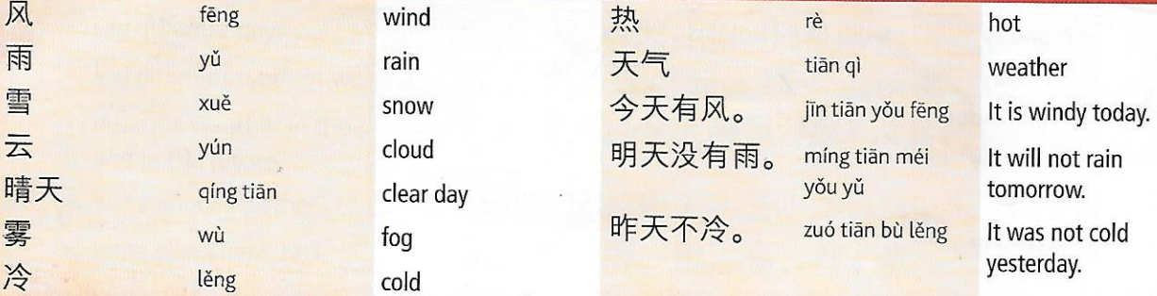

Countries

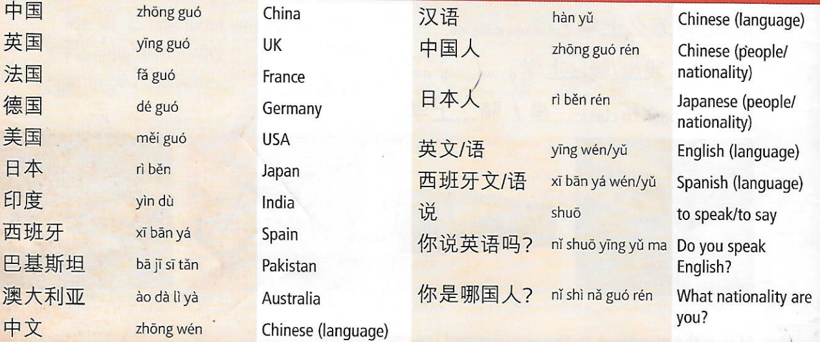

Holiday places and activities


