Year 9 Chinese Remote Learning Term 2
Week 1 02/11/2020 – 06/11/2020 Days of Week and Activities
Practise writing these characters
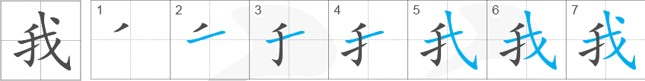 I/me
wǒ | 
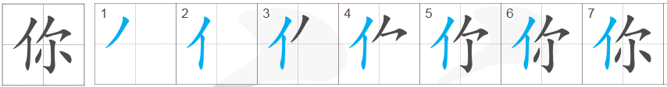 you
nǐ
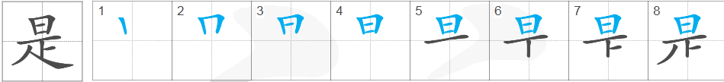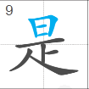 be/ is/am/are
shì
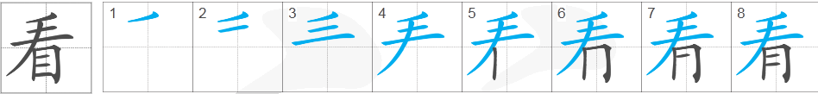 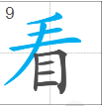 watch/look at
kàn
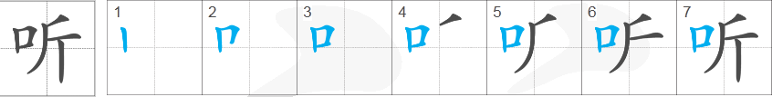 listen to
ting
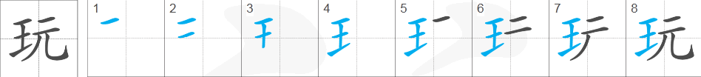 play
wán

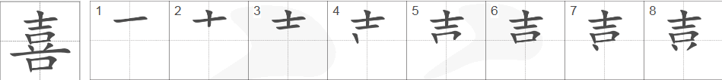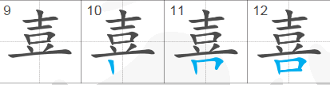
xǐ
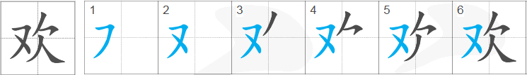 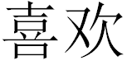 like
huān
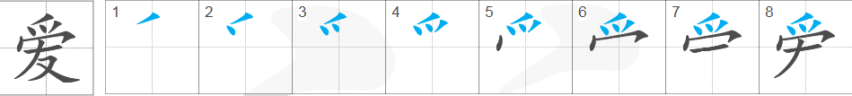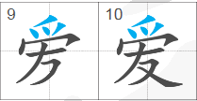 love
ài
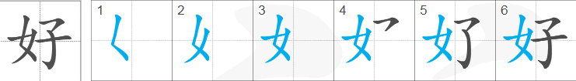  hobby
hào
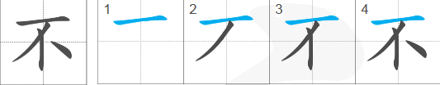 not
bù
1. Practice to write these characters. Follow the stroke order to write a whole character
2. Use the worksheet you used in lesson to help you to make the following sentences. (You have to write in Chinese characters)
1) My hobby is watching TV. 3) I don’t like to listen to music.
2) I like to play computer games.

Week 2 09/11/2020 -13/11/2020
My hobbies
1. Can you still remember? Write down these words in characters and Pinyin
Monday | Tuesday | Wednesday | Thursday | Friday | Saturday | Sunday

2. Fill out the table with Characters provided and translate them into English.
Characters | Pinyin | English | Characters | Pinyin | English
 | ài hào |  |  | shàng wǎng
 | kàn shū |  |  | wǎn diàn nǎo yóu xì
 | kàn diàn shì |  |  | wǎn huá bǎn
 | kàn diàn yǐng |  |  | xǐ huān
 | tīng yīn yuè |  |  | bù xǐ huān
 | mǎi dōng xī
Translate these sentences into English:
你的爱好是什么？nǐ de ài hào shì shén me
我的爱好是看书。wǒ de ài hào shì kàn shū
你喜欢看书吗？nǐ xǐ huān kàn shū ma?
Note：吗is a question word for “yes/no” questions
我喜欢看书。wǒ xǐ huān kàn shū
我不喜欢看书。wǒ bù xǐ huān kàn shū
Note: 不makes thing negative.

1. 看书 2.爱好 3. 看电视 4. 听音乐 5.看电影
6. 上网 7. 买东西 8.玩电脑游戏 9.喜欢 10.不喜欢

Week 3 19/11/2020 – 23/11/2020
Sports
1. Fill out the table with Pinyin and English equivalents.
运动 | yùn dòng |  | 什么 | shén me
篮球 | lán qiú |  | 跳舞 | tiào wǔ
足球 | zú qiú |  | 游泳 | yǒu yǒng
网球 | wǎng qiú |  | 打 | dǎ
乒乓球 | pīng pāng qiú |  | 踢 | tī
橄榄球 | gǎn lǎn qiú |  | 会 | huì
跑步 | pǎo bù |  | 不 | bù

2. Put Pinyin over the top of each word, then translate the sentences into English.

你喜欢什么运动？
我喜欢_____________。(play basketball)
你不喜欢什么运动？
我不喜欢_____________。(play football)
你会__________吗？(swim)
我会__________。
我不会___________。

The position of the time phrase
Days of the week |  |  | 不 | bù | not, most common negative form
星期 | xīng qī | week | 今天 | jīn tiān | today
星期一 | xīng qī yī | Monday | 我 | wǒ | I/me
Time phrases are placed at the beginning of the sentence or straight after the subject (person).
Subject (Person) + Time phrase+ verb + object
wǒ xīng qī yī dǎ wǎng qiú
我星期一打网球。
I Monday play tennis.
“不” is placed just before the verb.
wǒ xīng qī yī bù dǎ wǎng qiú wǒ shàng我星期一不打网球，我上
wǎng
网。
I Monday don’t play tennis, I surf the internet.

星期日星期天 | xīng qī rì  xīng qī tiān | Sunday
Use days of the week, hobbies and sports to make three sentences.

Week 4 23/11/2020 – 27/11/2020
Activities in Town
1. Match the place with the activities and learn the phrases

1) | 会朋友 | huì péng yǒu | meet friends | a | 剧院 | jù yuàn | theatre
2) | 看电影 | kàn diàn yǐng | watch a film | b | 电影院 | diàn yǐng yuàn | cinema
3) | 看话剧 | kàn huà jù | watch a drama | c | 音乐厅 | yīn yuè tīng | music hall
4) | 听音乐会 | ting yīn yuè huì | listen to a concert | d | 商店 | shāng diàn | shops
5) | 买东西 | mǎi dōng xī | do shopping | e | 饭馆 | fàn guǎn | restaurant
6) | 吃饭 | chī fàn | eat a meal | f | 运动中心 | yùn dòng zhōng xīn | sports centre
7) | 玩滑板 | wán huá bǎn | skate -boarding | g | 公园 | gōng yuán | park
8) | 做运动 | zuò yùn dòng | do sports | h | 镇上 | zhèn shàng | town

2. Learn some useful vocabulary: adverbs of frequency and adjectives. Practise writing these words from memory.
常常 | cháng chang | often | 有意思 | yǒu yì si | interesting
有时候 | yǒu shí hòu | sometimes | 好玩儿 | hǎo wánr | fun
很少 | hěn shǎo | rarely | 好看 | hǎo kàn | good to look/watch
从不 | cóng bù | never | 漂亮 | piào liàng | pretty
喜欢 | xǐ huān | to like | 去 | qù | to go
不喜欢 | bù xǐ huān | not like | 因为 | yīn wéi | because

Week 5 30/11/2020 -04/12/2020
How often - use adverbs of frequency and adjectives
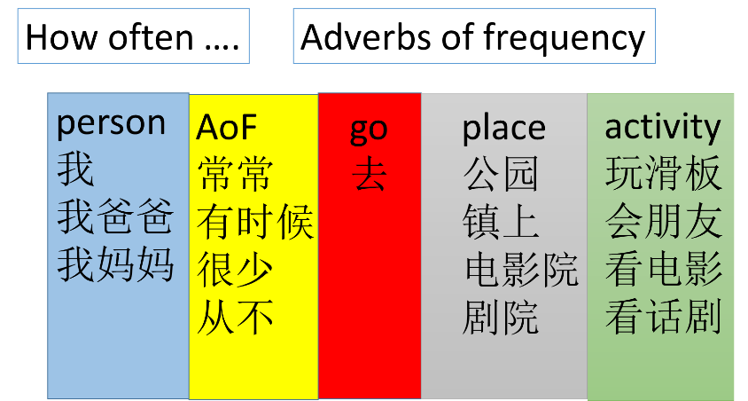
Fill the gaps with the words in the brackets.
a. 我_________(often) 去___________(park), 因为（yīn wéi, because）我___________(like) _____________(skate-boarding)。
b. 我___________ (sometimes) 去 ________ (town) ____________ (meet friends), 因为____________ (interesting)。
c. 我___________ (rarely) 去_____________(sports centre), ______________________________(because I don’t like sports)。
4. Write about the activities you do, please include:
- Where you often go and why
- Where you rarely go and why
- Where you never go and why

Week 6 07/12/2020 – 11/12/2020
Talk about films
1. Write down the English translation for each word.
恐怖片 |  | kǒng bù piān | 电影 | film | diǎn yǐng
科幻片 |  | kē huàn piān | 电影院 | cinema | diàn yǐng yuàn
爱情片 |  | ài qíng piān | 这 | this | zhè
喜剧片 |  | xǐ jù piān | 部 | measure word for “film” | bù
功夫片 |  | gong fū piān | 有 | to have | yǒu
动画片 |  | dòng huà piān | 什么 | what | shén me
战争片 |  | zhàng zhēng piān | 除了…以外，还有… | apart from…, also have… | chú le …yǐ wài, hǎi yǒu…
西部片 |  | xī bù piān | 想 | would like to | xiǎng
 |  |  | 去 | to go | qù
2. Learn the dialogue and use it to make your own. You may change the words in red to make your own version.
A. Hi, nǐ hǎo ma?
嗨，你好吗？
Hi How are you ?
B. hěn hǎo xiè xiè. nǐ ne?
很好，谢谢，你呢？
very good, thank you, and you ?
A. wǒ hěn hǎo. jīn tiān wǎn shàng, wǒ xiǎng qù diàn yǐng yuàn, nǐ xiǎng qù ma?
我很好。今天晚上，我想去电影院，你想去吗？
I am very good. Today night, I want to go to cinema. do you want to go ?
B. diàn yǐng yuàn yǒu shén me diàn yǐng ?
电影院有什么电影？
cinama has what films ?
A. shī zǐ wǎng, zhè shì yí bù dòng huà biān.
狮子王，这是一部动画片。
lion king, this is one animated film.
B. ào, wǒ bù xǐ huān dòng huā piān. chú le zhè bù diàn yǐng yǐ wài, hái yǒu shén me diàn yǐng?
嗷，我不喜欢动画片。 除了这部电影以外，还有什么电影？
oh, I don’t like animated films. Apart from this film, also has what film ?
A. OK,hǎi yǒu Rush Hour. zhè shì yí bù xǐ jù piān.
OK，还有Rush Hour。这是一部喜剧片。
OK, also has rush hour, this is one comedy.

B. hǎo ba. wǒ hěn xiǎng kàn zhè bù. wǒ tè bié xǐ huān xǐ jù piān
好吧。我很想看这部。我特别喜欢喜剧片。
good, I very want to watch this film, I especially like comedy.

Week 7 14/12/2020 – 18/12/2020
Learning a song: Jingle Bells
JINGLE BELLS IN CHINESE
冲破大风雪, 我们坐在雪橇上
chong guò dà fēng xuě; wŏmen zuò zài xuě qiāo shàng
快奔驰过田野, 我们欢笑又歌唱
Kuài bèn chí guò tiányě ， wŏmen huānxiào yòu gē chàng
马儿铃声响叮当， 令人精神多欢畅
Mă’ér ling shēng xiǎng dīng dāng lìngrén jīng shén duō huān chàng
我们今晚滑雪, 真快乐把滑雪歌儿唱
wǒ men jīn wǎn hua xuě， zhēn kuài lè bǎ hua xuě gē ér chàng,

叮叮当叮叮当，令儿响叮当
dīng dīng dāng dīng dīng dāng ling ér xiǎng dīng dāng
今晚滑雪多快乐, 我们坐在雪橇上
jīn wǎn hua xuě duō kuài lè， wŏmen zuò zài xuě qiao shàng
叮叮当叮叮当，令儿响叮当
dīng dīng dāng dīng dīng dāng líng shēng xiǎng dīng dāng
今晚滑雪多快乐, 令儿响叮当
jīn wǎn hua xuě duō kuài lè, ling ér xiǎng dīng dāng
今晚滑雪多快乐, 我们坐在雪橇上
jīn wǎn hua xuě duō kuài lè, wŏmen zuò zài xuě qiao shàng

如今白雪遍地, 趁这少年好时光
rújīn bái xuě biàndì ，chèn zhe shào nián hǎo shí guāng
带上亲爱的朋友，趁这少年好时光
Dàishàng qīn'ài de péngyou , chèn zhe shào nián hǎo shí guāng
带上亲爱的朋友，把滑雪歌儿唱
Dàishàng qīn'ài de péngyou , bǎ hua xuě gē ér chàng
有一匹栗色马,它日行千里长
Yŏu yī pǐ lìsè mă， tā rì xíng qiān lì cháng
我们把它套在,雪橇上就飞奔向前方
wŏmen bǎ tā tào zài， xuĕ qiāo shàng jiù fēi bēn xiàng qián fāng
叮叮当叮叮当，令儿响叮当
dīng dīng dāng dīng dīng dāng ling ér xiǎng dīng dāng
今晚滑雪多快乐, 我们坐在雪橇上
jīn wǎn hua xuě duō kuài lè， wŏmen zuò zài xuě qiao shàng
叮叮当叮叮当，令儿响叮当
dīng dīng dāng dīng dīng dāng líng shēng xiǎng dīng dāng
今晚滑雪多快乐, 令儿响叮当
jīn wǎn hua xuě duō kuài lè, ling ér xiǎng dīng dāng
今晚滑雪多快乐, 我们坐在雪橇上
jīn wǎn hua xuě duō kuài lè, wŏmen zuò zài xuě qiao shàng

http://www.tudou.com/programs/view/LANA-QMBsjw/

