
Art Remote Learning Lesson
Y9 Political Art 4 Keith haring

Print off the sheet to work on or do the task on plain paper or in your book. Bring your work to your next lesson.

Starter
Describe what you think this work might be about. What is the artist trying to say or highlight? __________________________________________________________________________________________

___________________________________________________________________________________________
Main Task
Using a pencil and colouring pencils, try to copy the design below in the space next to it, as accurately as possible. Choose 4 questions from the Hots sheet, 1 from each section and answer them fully about the image below.
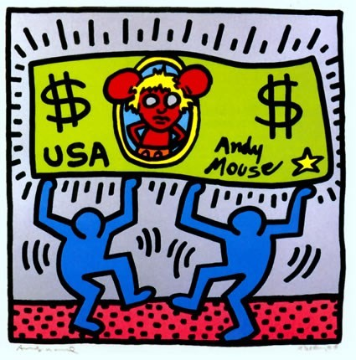

Draw in this square

Extension: Create your own personal response digitally (on the computer) or physically (with felt tips or colouring pencils). What message would you like to say?

Plenary
This artist links to our project because (write why you think it links to our project)…………………………………………………………………………………………………………………..............................................................................................................................................................................................................................................................................................................................................
………………………………………………………………………………………………………………………….
………………………………………………………………………………………………………………………….

