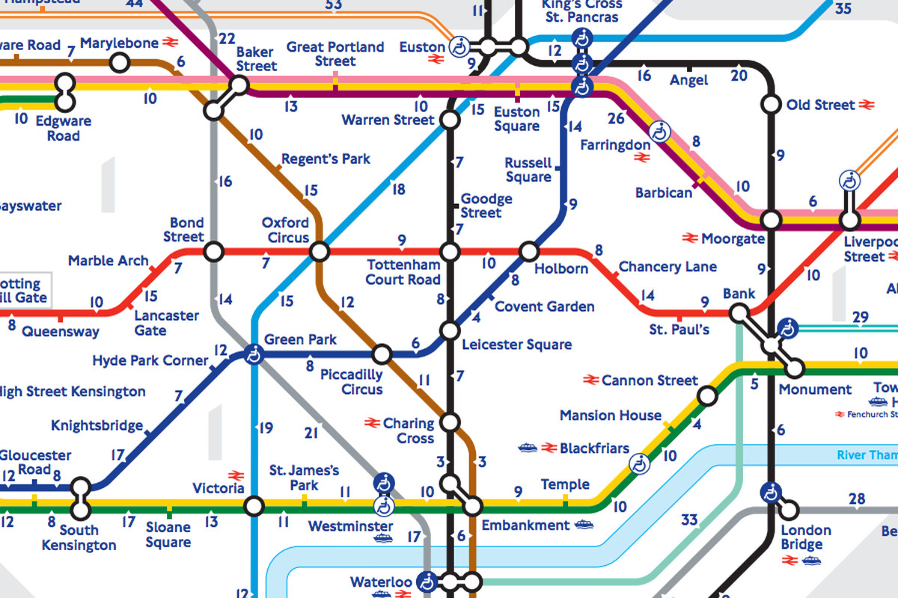
LONDON UNDERGROUND MAP

