Moments
Draw a picture of a see saw and label it with the following things

- The fulcrum (where the see saw is attached to the pivot)
- The pivot
- Draw two characters of different sizes and give them different forces and distances from the pivot.
- Show how you would calculate the moment of each character using the equation from the lesson.
- Below is an example to help you.
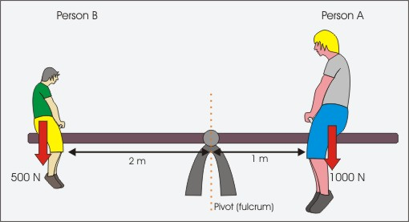

Calculate the moment on the following seesaws (level4)
10N 1.5m
5N 4m

20N 40m
4m 2N

Decide if the following seesaws are balanced or say which side goes up and which side goes down (level 5)

2N 4m
2N 40m
4m 20N
3m 2N

0.8N 4.5m
2N 0.75m
7.3m 0.2N
4m 0.5N

Design two seesaw problems for your friends

Cranes and moments- Calculate the moments involved in the following pictures



