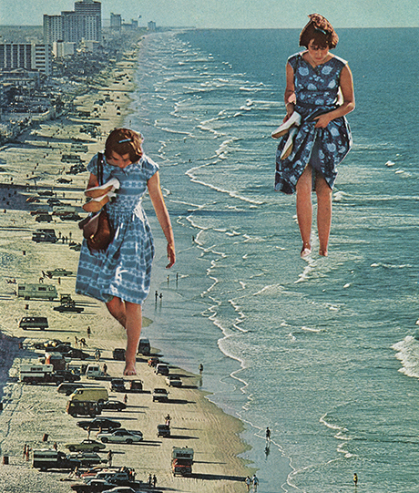
Art Remote Learning Lesson
Year 8 In A Different Way 5

Print off the sheet to work on or do the task on plain paper or in your book. Bring your work to your next lesson.

STARTER
State the main Formal Elements in Art you can see in this surreal collage by Sarah Eisenlohr. Describe how the image links to your project and explain why it is surreal. ____________________________________________________
________________________________________________
____________________________________________________
Main
Using media of your choice, draw and colour image in the space below, as accurately as possible. Choose 4 questions from the Hots sheet, 1 from each section and answer them fully about the image.
Extension: Create your own surreal collaged scene here. You can do it on A4 if you wish. You can do it on a computer if you like.

Plenary

WWW: ______________________________

EBI:___________________________

