**Surface area to volume ratios**

Volume = length x width x height

Surface Area = length x width

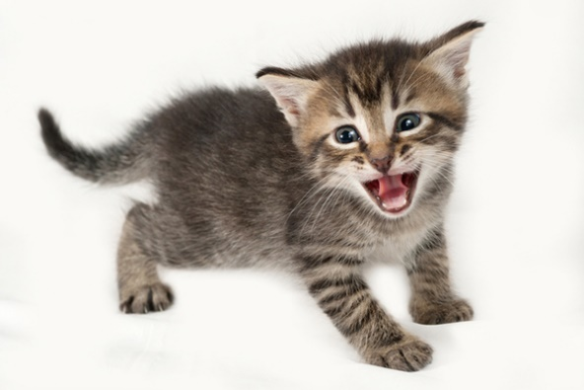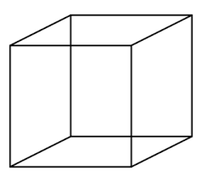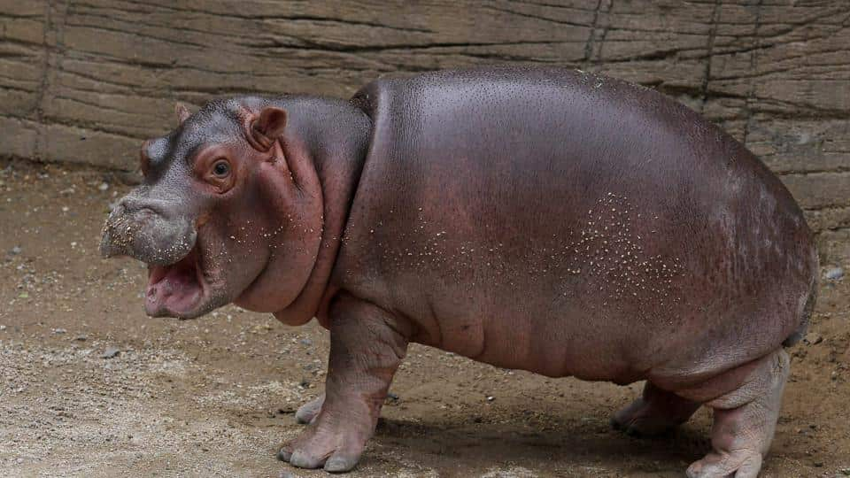

4)

3)

2)

1)

An elephant has a surface area of 25m2 and a volume of 10m3. Whereas a Pidgeon has a surface area of 0.5m2 and a volume of 0.05m3. Which animal has the larger surface area to volume ratio?

__________________________________________________________________________________________________________________________________________________________________________________________________________________________________________________________________________________________________________________________________________

Calculate the surface area to volume ratio of this kitten.

_________________________________________________________________________________________________________________________________________________________________________________________________

4cm

5cm

6cm

Calculate the surface area to volume ratio of this box.

_____________________________________________________________________________________________________________________________________________________________________

40cm

30m

30m

When calculating the surface area and volume of an animal we can imagine they are a box. Treating this Hippo like this calculate its surface are to volume ratio.

____________________________________________________________________________________________________________________________________

1m

2m

0.5mm