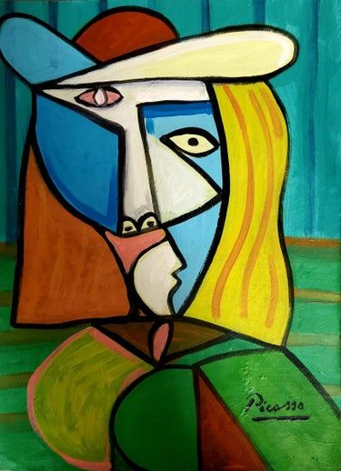
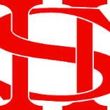
Art Remote Learning Lesson
Year 8 In A Different Way 6

Print off the sheet to work on or do the task on plain paper or in your book. Bring your work to your next lesson. If you are doing it on paper or in your book do the whole image.

STARTER
State the main Formal Elements in Art you can see in this cubist painting by Picasso. Describe how the image links to your project. ____________________________________________________________
____________________________________________________________
____________________________________________________________
Main
Using media of your choice, draw and colour the painting in the space below, as accurately as possible. Choose 4 questions from the Hots sheet, 1 from each section and answer them fully about the image.

Extension: Create your own Cubist style portrait here. You can do it on A4 if you wish.

Plenary

WWW: ______________________________

EBI:___________________________

