Art Remote Learning Lesson
Y8 Environment 4

Print off the sheet to work on or do the task on plain paper or in your book. Bring your work to your next lesson.

Starter
State the main Formal elements in Art you can see in this artwork by Eduardo Paolozzi and describe how you will recreate it. ________________________________________________________________
___________________________________________________________________________________________
Main Task
Using pencil, try to copy the design below in the space next to it, as accurately as possible. Or enlarge and draw a section of it. Choose 4 questions from the HOTS sheet to answer about the image above.
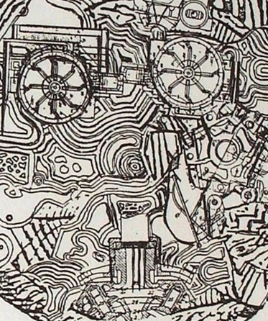

Extension: Do a close-up section in PEN here. Colour it.

Plenary

What Went Well:

Even Better:

