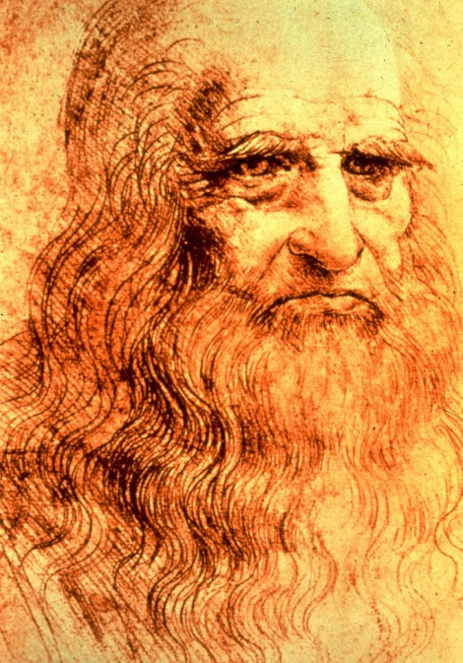
Art Remote Learning Lesson
Year 7 Identity 1

Print off the sheet to work on or do the task on plain paper or in your book. Bring your work to your next lesson. If working on plain paper do the whole image.

STARTER
State the main Formal elements in Art you can see in this drawing by Leonardo Da Vinci, and describe how you will use your pencil to recreate it. How does this work link to our project?________________________________________________________
_______________________________________________________________

Main
Using pencil, draw the rest of the sketch below, as accurately as possible.
Choose 4 questions from the Hots sheet, 1 from each section and answer them fully about the image.

Extension: Draw a portrait of yourself or someone at home, in the same style here.

Plenary

What Went Well:

Even Better if:

