Art Remote Learning Lesson
Y7 Culture 6 – Indian Art
Print off the sheet to work on or do the task on plain paper or in your book. Bring your work to your next lesson.
Elephants were highly valued by the rulers of India, for their power in battle and their majestic dignity as ceremonial mounts. From around 1570 to 1750, many superb elephant portraits or studies of elephants in action were painted by the court artists of the Mughal emperors, the Deccani sultans or the Hindu Maharajas of Rajasthan.
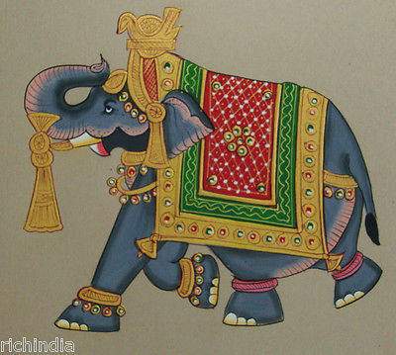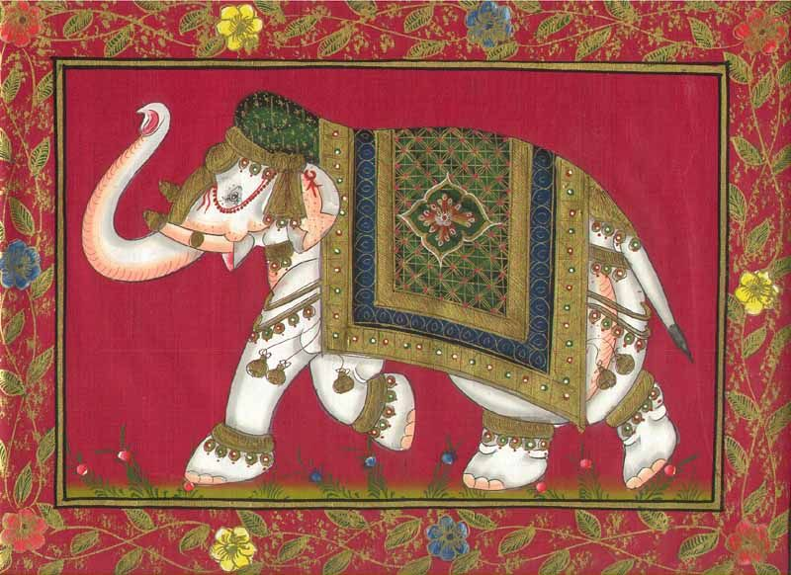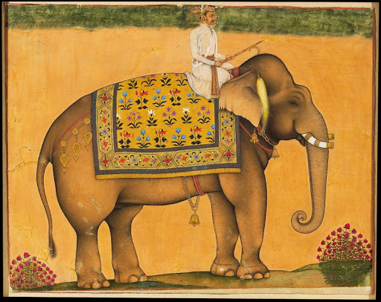
Starter
What animal do you think we value most in our culture today and why do you think this?
__________________________________________________________________________________________
Main Task
Design your own decorated elephant using the outline provided. Look at the examples of Indian patterns to help you.Colour it with pencil or pen. Choose 4 questions from the HOTS sheet to answer about one of the images above.

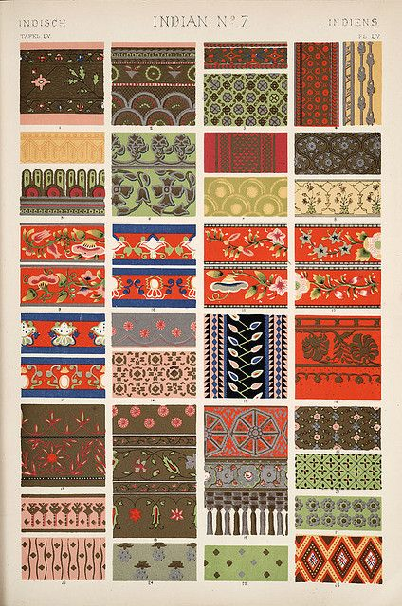

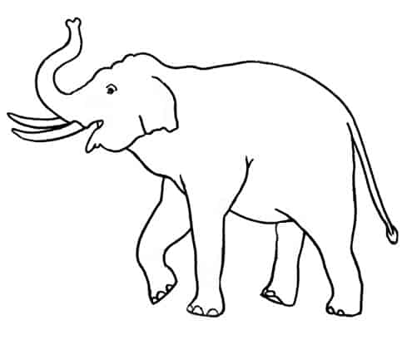

Extension: Add a patterned border and a background
Plenary
What Went Well:

Even Better:

