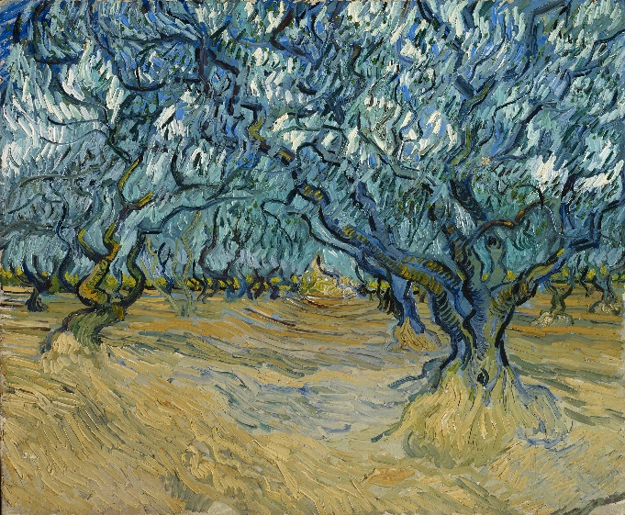
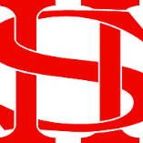
Art Remote Learning Lesson
Y8 Environment 1

Print off the sheet to work on or do the task on plain paper or in your book. Bring your work to your next lesson. If working on plain paper do the whole image.
Starter
State the main Formal element in Art you can see in this portrait by Vincent Van Gogh and describe how you will use your pencil to recreate it. _________________________________________________
_________________________________________________
Main Task
Using pencil, draw the rest of the portrait below, as accurately as possible. Choose 4 questions from the HOTS sheet to answer about the image above.

Extension: Do a close-up section in PEN here.

Plenary

What Went Well:

Even Better:

