Art Remote Learning Lesson
Y7 Culture 5 – Greek Art
Print off the sheet to work on or do the task on plain paper or in your book. Bring your work to your next lesson.
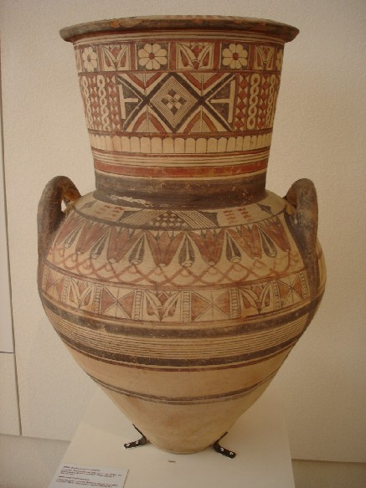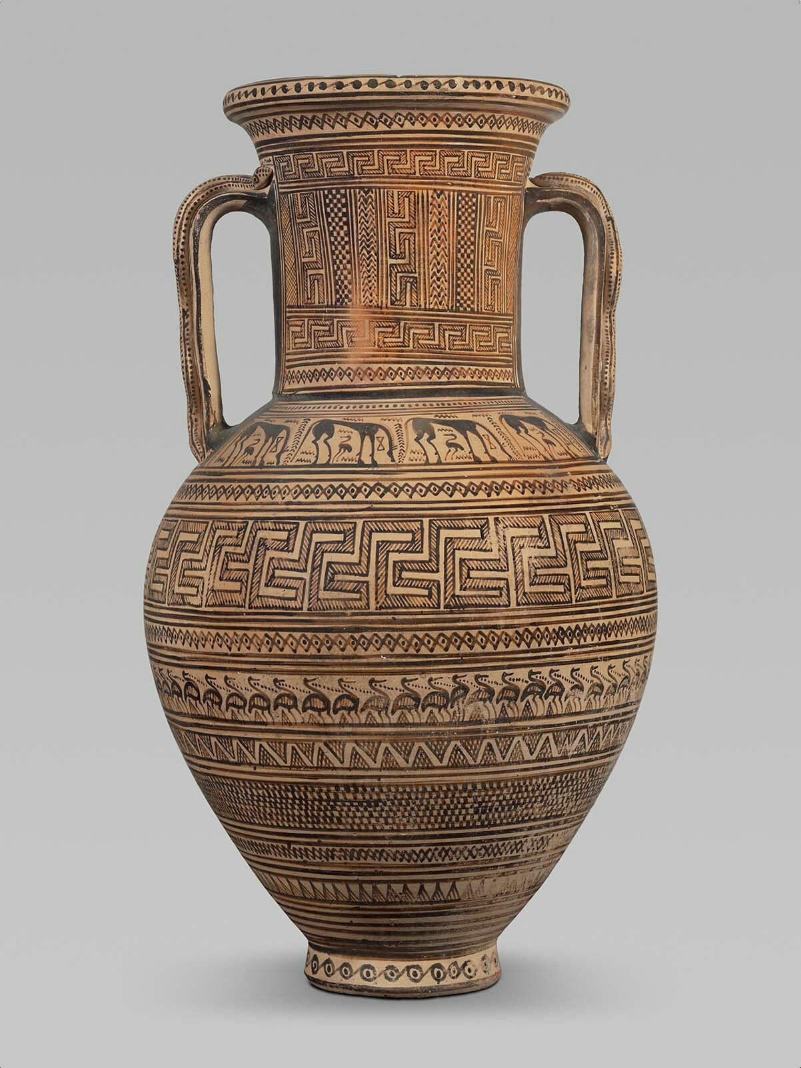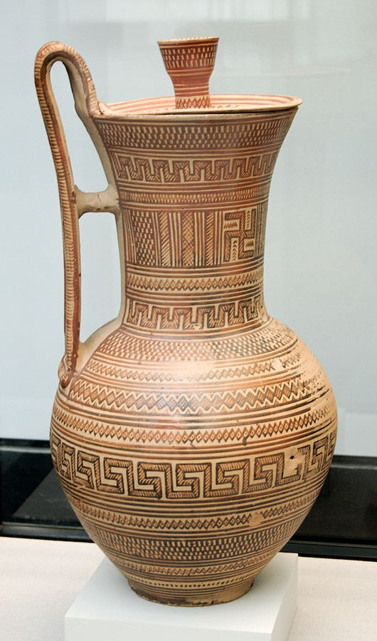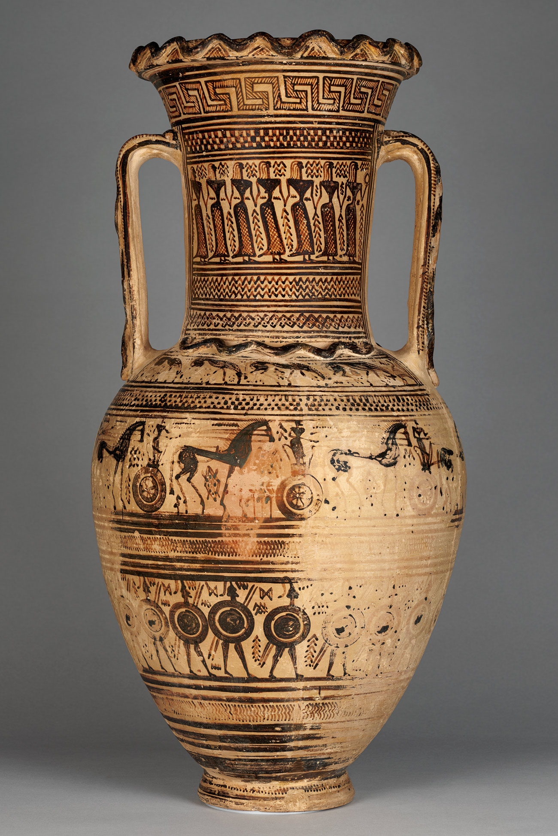
Starter
What is the most important Formal element being used in these Greek Vases?
___________________________________________________________________________________________
Main Task
Design your own Greek Vase in the outline provided. Look at the examples of Greek patterns to help you. Colour it in traditional natural colours. Choose 4 questions from the HOTS sheet to answer about one of the vases above.

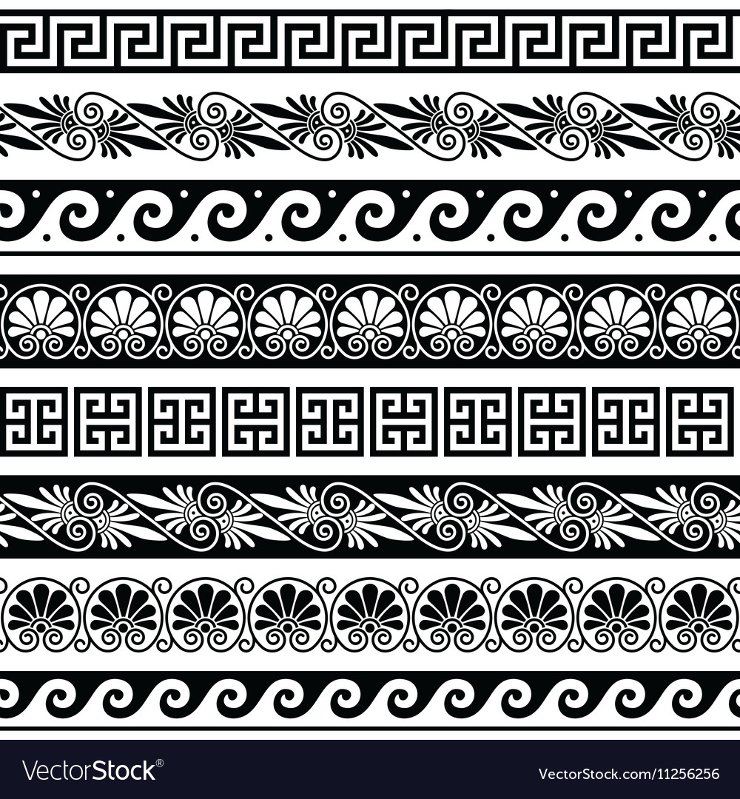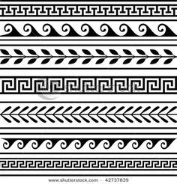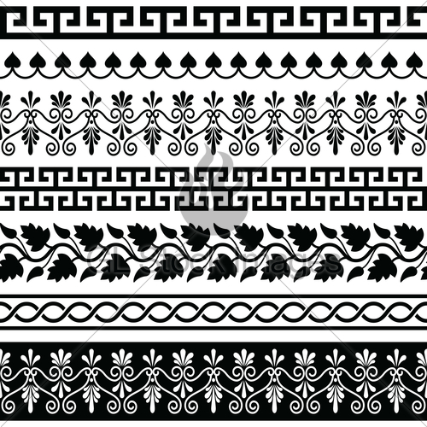
Extension: Design some different shapes for the outline of your vase and complete another design. This time, use bright and lively colours.
Plenary
What Went Well:

Even Better:

