Lesson Listening and reading practice
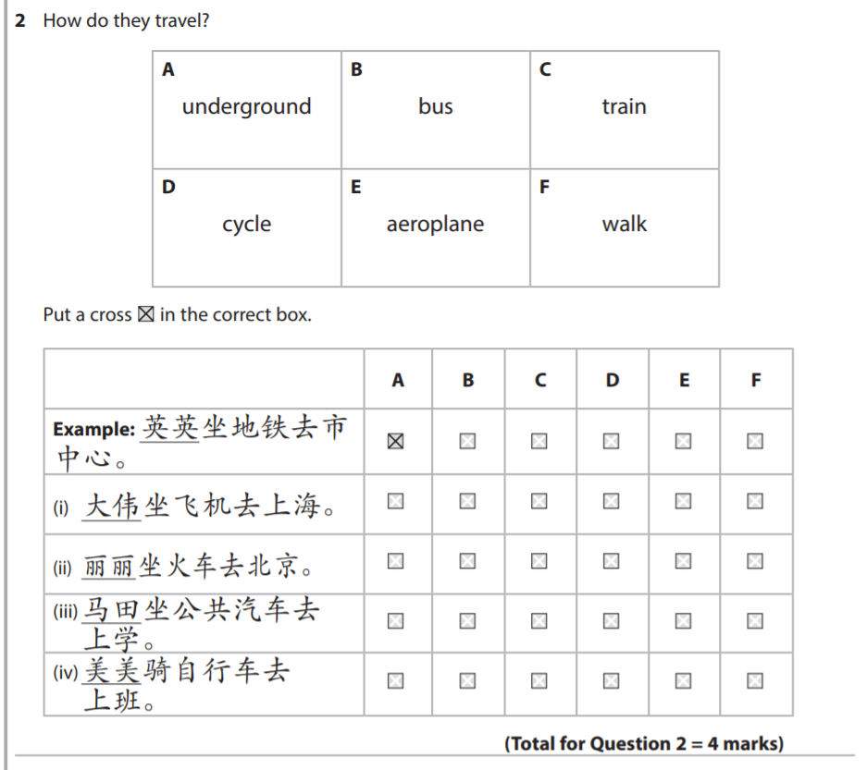
Read the text and answer the questions.
北京一年有四个季节: 春天、夏天、秋天、冬天。 北京的春天，天气很好，但是风很大。夏天的天气热。 七月、八月常常下雨。北京有很多游泳的地方。每年 夏天，游泳的人也很多。北京的冬天很冷，但是不常 下雪。北京的冬天也可以溜冰。秋天是去北京旅游最好的季节。
1. How many seasons are there in Beijing?
2. What is the weather like in Beijing in spring?
3. Give two facts about Beijing’s summer.
4. What is the weather like in Beijing in Winter? And what you can do?
5. When is the best for sightseeing in Beijing?
