Art Remote Learning Lesson
Y9 Skills workshop 1

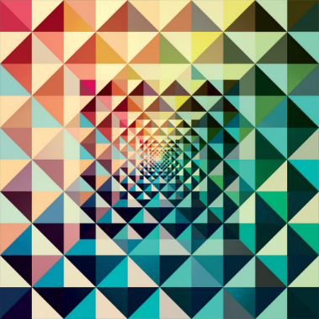
Print off the sheet to work on or do the task on plain paper or in your book. Bring your work to your next lesson.
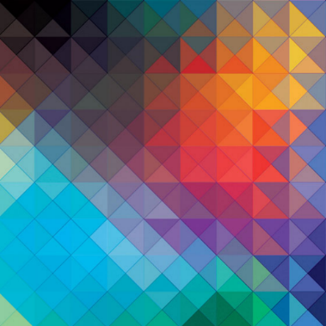
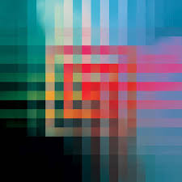

Starter
In the three images by Andy Gilmore, what are the main formal elements used? Circle the ones you think -
LINE TONE COLOUR TEXTURE SHAPE PATTERN FORM
Main Task
Use the squared paper below to design your own geometric design inspired by Andy Gilmore and colour it. Choose 4 questions from the Hots sheet, 1 from each section and answer them fully about one of the images above.

Extension: Can you create one using circles?

Plenary
Describe the composition of your pattern? Why did you choose the colours that you used?
…………………………………………………………………………………………………………………......................................................................................................................................................................................................................................................................................................................................................................

